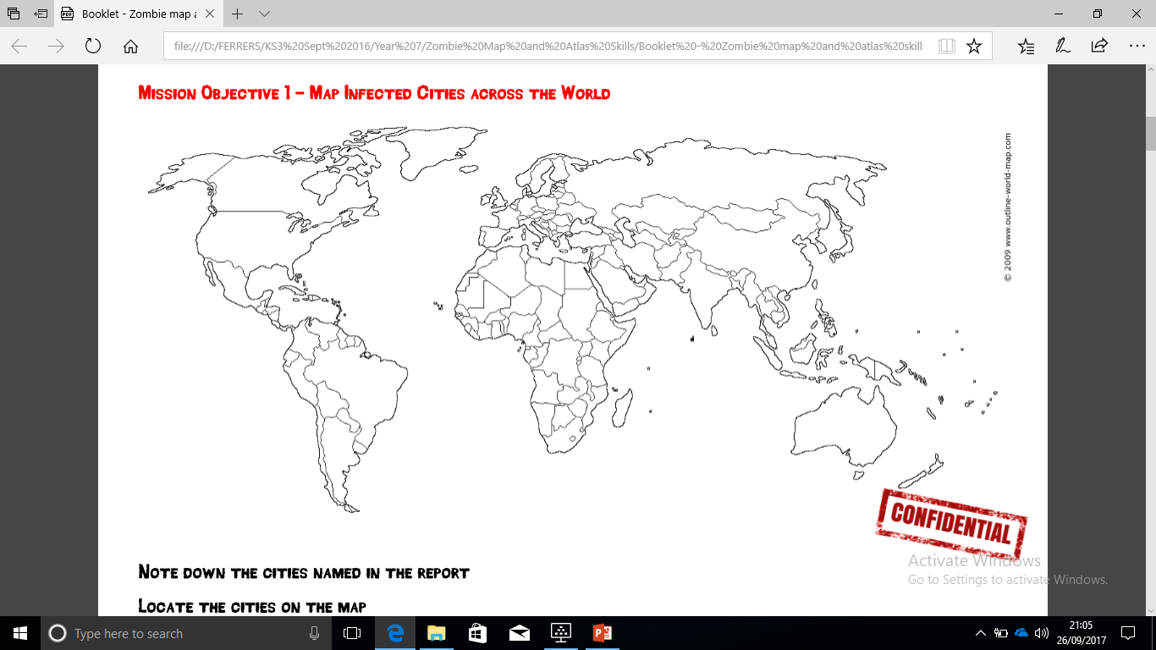

**Mission 1: Cities invaded:**

1. Beijing. 2. Hong Kong. 3. Bangkok. 4. Dhaka 5. New Delhi.

6. Mumbai. 7. Kathmandu. 8. Islamabad 9. Karachi.

10. Kabul. 11. Baghdad 12. Tehran.

**Some of the locations invaded are located on your map – can you complete the map to achieve mission 1?**

* **Challenge yourself:** Can you describe the spread of the zombies so far?

*Think about:* Countries invaded so far, continents invaded so far, what hemisphere has been invaded so far.

12.

9.

10.

7.

6.

5.

3.

2.

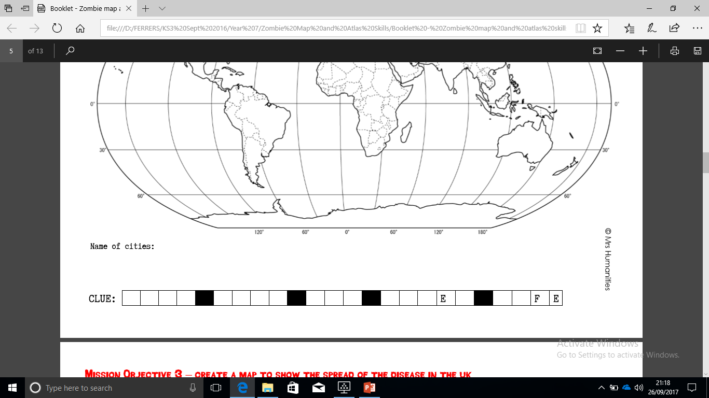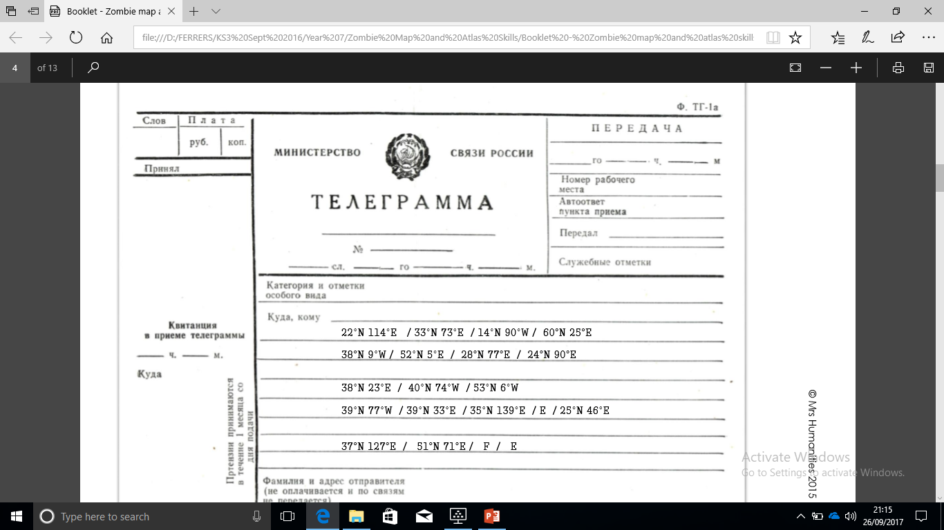

**Hint:**

**1: Hong Kong**

**2: Islamabad…**

**8: Dhaka**

**18: Astana**

**Mission 2: How to keep safe: Solve the clue! Find the missing locations…**

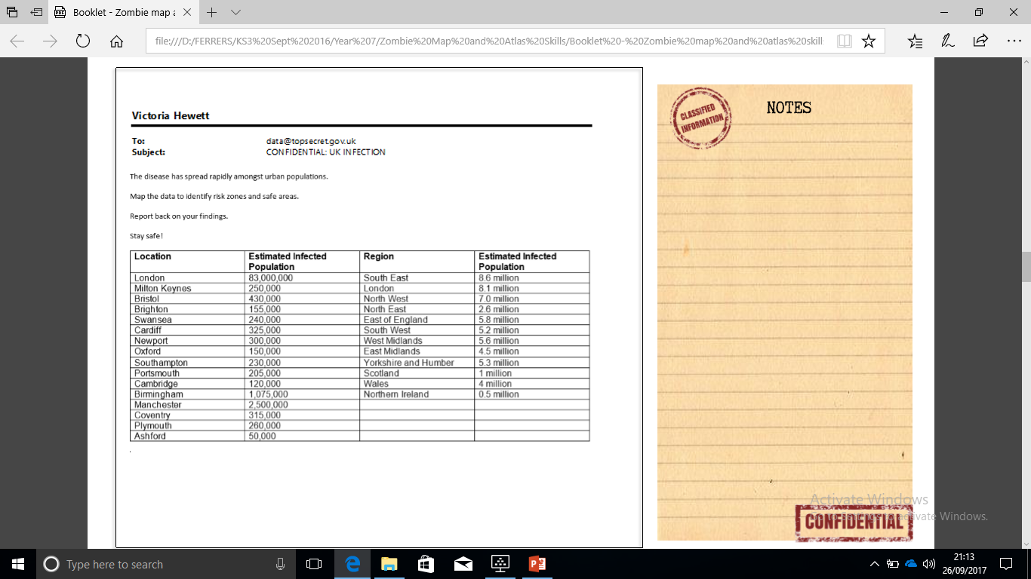

**Missions 3 and 4: Where in the UK?**

The zombies have spread rapidly amongst urban populations.

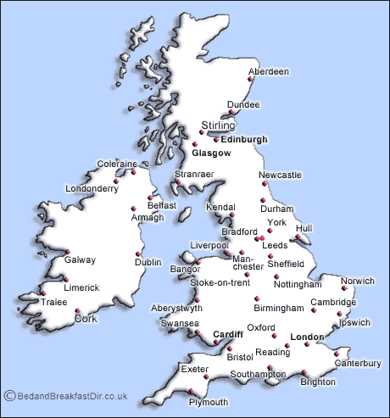

C

N

P

M

M

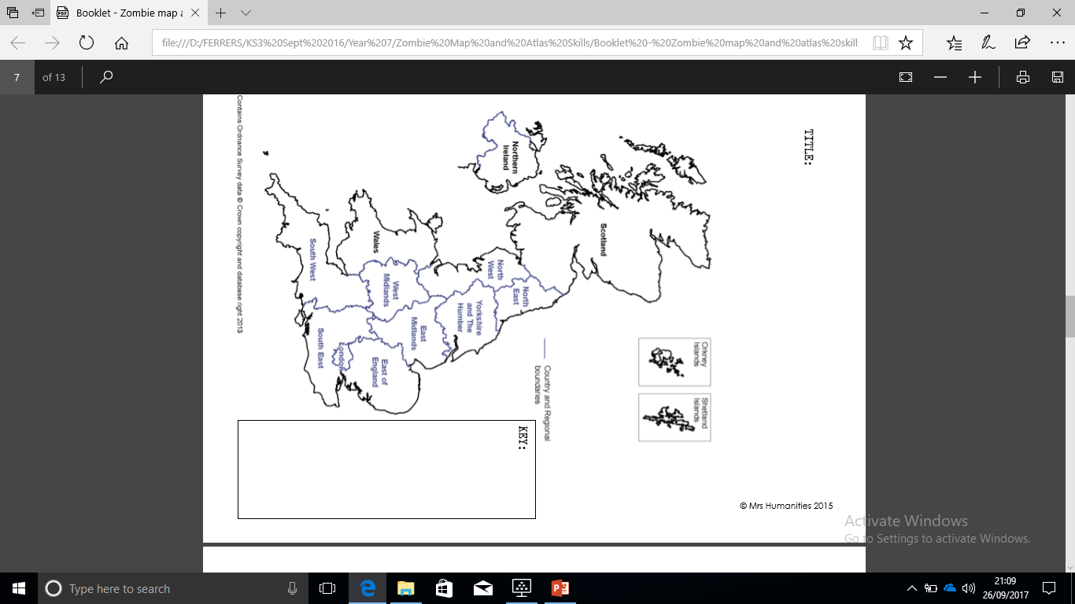

C

N

M

A

P

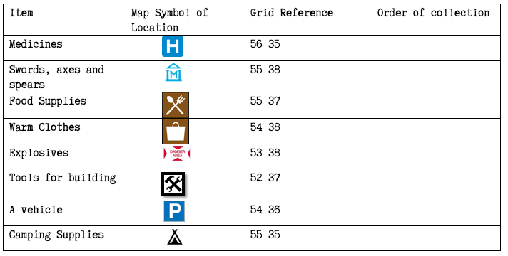

|  |  |
| --- | --- |
| Grid reference: | Order of collection: |
|  |  |
|  |  |
|  |  |
|  |  |
|  |  |
|  |  |
|  |  |
|  |  |

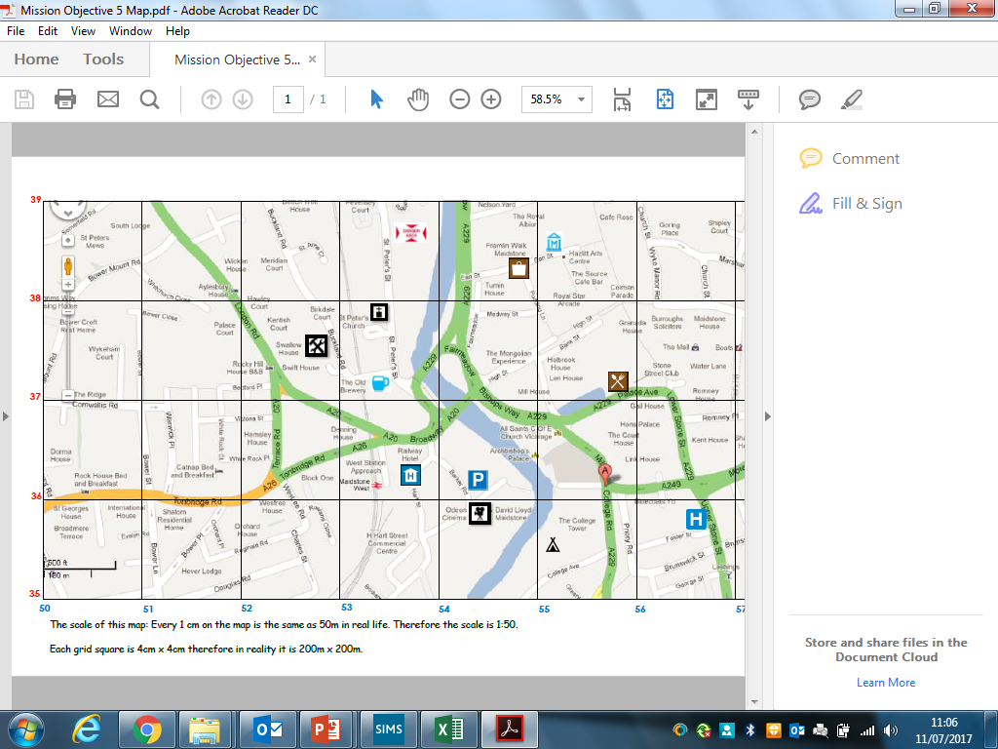

**Mission 6: Mapping our route to supplies…**