Y5 Priority Therapy
Y5 R1e Can compare and evaluate different texts against their intended purpose
Test 2

Commissioned by The PiXL Club Ltd.
May 2018
This resource is strictly for the use of member schools for as long as they remain members of The PiXL Club. It may not be copied, sold nor transferred to a third party or used by the school after membership ceases. Until such time it may be freely used within the member school.
All opinions and contributions are those of the authors. The contents of this resource are not connected with nor endorsed by any other company, organisation or institution.
PiXL Club Ltd endeavour to trace and contact copyright owners. If there are any inadvertent omissions or errors in the acknowledgements or usage, this is unintended and PiXL will remedy these on written notification.

© Copyright The PiXL Club Limited, 2018

Y5 R1e Child as a reader Test 2
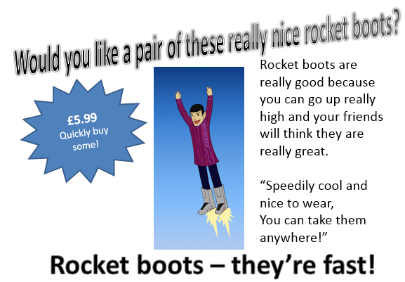
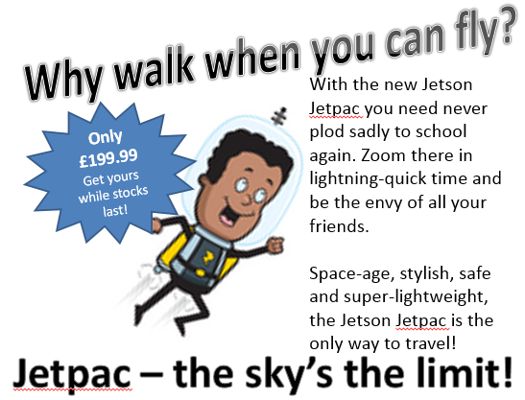

- Which text type do these two pieces of writing represent?

_____________________________________________________________________

- What is the purpose of these texts?

_____________________________________________________________________

_____________________________________________________________________

- Compare the two texts and decide which you think is the most successful and why. Explain your answer giving evidence from the text – remember to make reference to the features of this text type.

_____________________________________________________________________

_____________________________________________________________________

_____________________________________________________________________

_____________________________________________________________________

_____________________________________________________________________

Y5 R1e Child as a reader Test 2 – ANSWERS

Qu. | Answer
1 | persuasive, advert
2 | to persuade the reader to buy the item
3 | Jetpac Jetson is the most successful  - e.g. engaging rhetorical question, eye-catching image, catchy slogan, deal which suggests urgency, exaggeration, alliteration …

