Year 4 Reading Skills Test 2

R1d. Recognises similarities and differences between texts structured in different ways

Commissioned by The PiXL Club Ltd.
August 2018
This resource is strictly for the use of member schools for as long as they remain members of The PiXL Club. It may not be copied, sold nor transferred to a third party or used by the school after membership ceases. Until such time it may be freely used within the member school. All opinions and contributions are those of the authors. The contents of this resource are not connected with nor endorsed by any other company, organisation or institution. If there are any inadvertent omissions or errors in the acknowledgements or usage, this is unintended and PiXL will remedy these on written notification.

© Copyright The PiXL Club Limited, 2018

It’s kind to say you’re sorry  It’s kind to say you’re sorry  when you’ve made a big mistake:  The mess you made, the toy you broke,  Or when you dropped the cake.  A simple word, that’s all it takes  No need to write a letter.  Though ‘sorry’ might not put it right,  It might just make it better. | It’s kind to say you’re sorry  It’s kind to say you’re sorry when you’ve made a big mistake: The mess you made, the toy you broke, or when you dropped the cake. A simple word, that’s all it takes no need to write a letter. Though ‘sorry’ might not put it right, it might just make it better.

- Compare the two versions of the poem, how has the structure changed? What is the effect of this change?

_____________________________________________________________________

_____________________________________________________________________

____________________________________________________________________

Bats (extract of a report)
Living
Bats use different roosts for different activities. Some have special maternity roosts where they rear their young. Some migrate long distances to spend the winter in warmer climates. Trees and caves have always been typical bat roosts, but more recently, some have been using manmade structures such as houses and churches as a place to call home.
Protection
Bats are not just fascinating – they’re useful too. A number of plant species rely on nectar-drinkers to help pollinate their flowers, or fruit bats to make sure their seeds are properly dispersed. Little wonder, then, that many bats species are highly valued by humans and, here in the UK, they are protected by law.
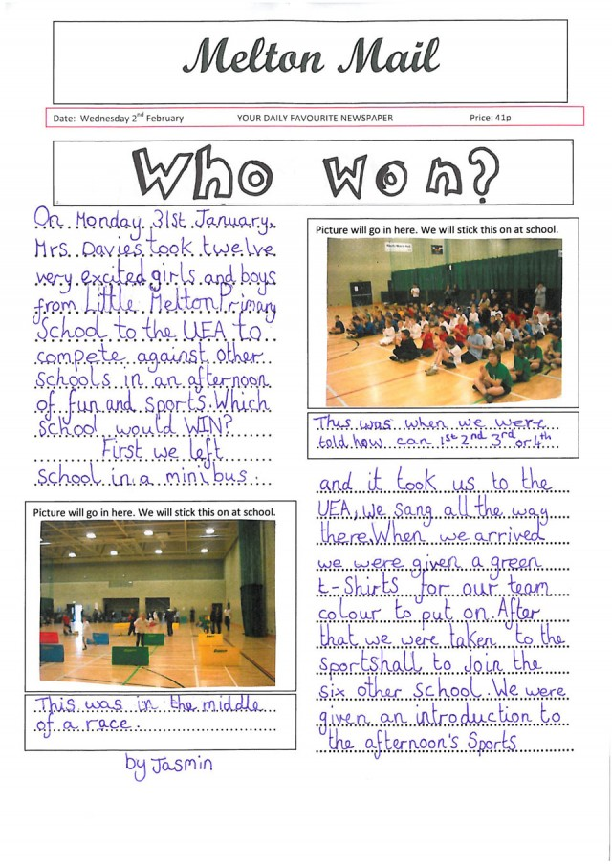

- Explain a reason why these two texts are organised in different ways?

_____________________________________________________________________

_____________________________________________________________________

_____________________________________________________________________

- What is similar between these texts?

_____________________________________________________________________

_____________________________________________________________________

_____________________________________________________________________

Y4 R1d. Recognises similarities and differences between texts structured in different ways Test 2 – ANSWERS

Qu. | Answer
1 | The first poem is organised in lines ending with words that will rhyme with previous lines. The second version is organised as a continuous narrative. The effect of this change is there is less emphasise on the rhyme and some of the rhythm is lost.
2 | The first text is an extract from a report. It uses sub-headings and paragraphs to organise the information. This makes it easy for the reader to find the information they need. The second text is a newspaper report and is structured to attract attention (headline) and it is intended that the reader will read the whole story, so they do not need sub-headings to signpost different sections.
3 | They are both reports and include facts. Information is organised in in chronological order in the newspaper report whilst the information in the report is not.

