Y4 Priority Therapy
Y4 R6e Can evaluate the overall quality of a text, as well as the inclusion of specific features
Test 1

Commissioned by The PiXL Club Ltd.
May 2018
This resource is strictly for the use of member schools for as long as they remain members of The PiXL Club. It may not be copied, sold nor transferred to a third party or used by the school after membership ceases. Until such time it may be freely used within the member school.
All opinions and contributions are those of the authors. The contents of this resource are not connected with nor endorsed by any other company, organisation or institution.
PiXL Club Ltd endeavour to trace and contact copyright owners. If there are any inadvertent omissions or errors in the acknowledgements or usage, this is unintended and PiXL will remedy these on written notification.

© Copyright The PiXL Club Limited, 2018

Y4 R6e Can evaluate the overall quality of a text, as well as the inclusion of specific features Test 1
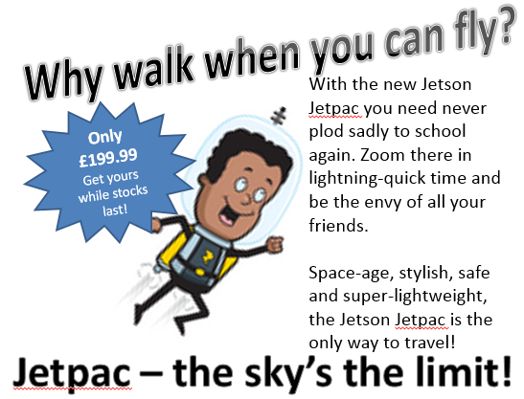

- What is the purpose of an advert?

_____________________________________________________________________

- Tick which are the features of an advert below.

sub-headings |  | special offers
rhetorical questions |  | dialogue
colourful and eye-catching |  | alliteration
paragraphs |  | bullet points
superlatives e.g. the greatest |  | customer testimonials

- Do you think this advert is persuasive? Why?

_____________________________________________________________________

_____________________________________________________________________

- Find and copy the part which you think is the most persuasive.

_____________________________________________________________________

Y4 R6e Can evaluate the overall quality of a text, as well as the inclusion of specific features Test 1 – ANSWERS

Qu. | Answer
1 | to persuade
2 | sub-headings special offers  rhetorical questions dialogue  colourful and eye-catching alliteration  paragraphs bullet points  superlatives e.g. the greatest customer testimonials
3 | Yes – it has a rhetorical question, a special offer, alliteration and adjectives/verbs to tell you how great it is (accept any answer which makes references to features in the advert)
4 | Accept any part of the advert

