Reading extract and questions:
Year 2
The United Kingdom.
Set A/B

Introduction
The UK is where we live. UK is short for the United Kingdom of Great Britain and Northern Ireland.
It is made up of four countries – England, Northern Ireland, Scotland and Wales. Each one has its own capital city – London for England, Belfast for Northern Ireland, Edinburgh for Scotland and Cardiff for Wales.
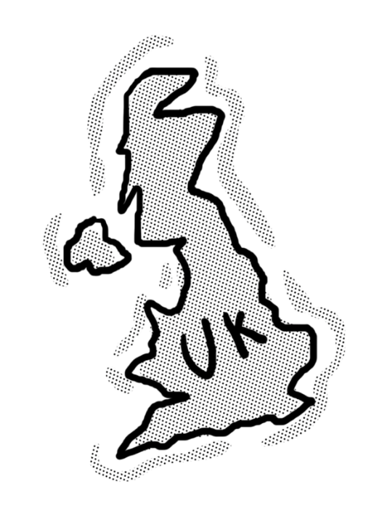
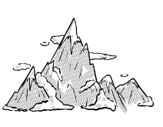
Northern Ireland
This is the only country which is not on the mainland of Great Britain. It is part of the island of Ireland. Northern Ireland has lots of stunning countryside. It also has the largest lake in the UK called Lough Neagh. Cloud-carrying winds from the Atlantic Ocean mean it is often wet and overcast there.
North
Scotland
The country in the north of the UK
is Scotland. A large part of it is
covered with towering mountains, which is why it is often called the Highlands. The weather tends to be colder than the rest of the UK and they get the most snow there in the winter months.

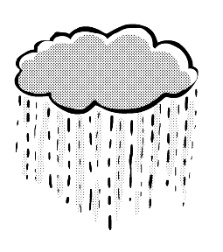
East
West
England
England is the largest of the four countries that make up the United Kingdom. It tends to be warmer and drier than the rest of the UK, especially towards the south and east. It is mainly covered with lowlands and gently rolling hills. More people live in England than any other country in the UK. The longest river in England is the River Thames. It is 215 miles long.
Wales
Wales is a green, hilly country on the western side of Great Britain. The highest mountains are in the north, the tallest of which is Mount Snowdon. Lots of people visit Wales to go mountain climbing. Although people in Wales mainly speak English, Wales actually has two main languages. Welsh is spoken by over half a million of the three million people who live there. Visitors will notice that road signs are usually written in both languages.
South

Seas and oceans
The UK is surrounded by water. The Irish Sea is in between Northern Ireland and Great Britain. The English Channel (to the south) lets us travel to France and the North Sea is to the east between Scotland and England. A lot of Scotland’s coast is attacked by the ferocious waves of the Atlantic Ocean.

Questions for
The United Kingdom
Set A
Vocabulary:

1. Each one has its own capital city … In this sentence, capital means … Tick one.

tall main

old rich

2. Look at the Scotland fact box. Find and copy a word that means high.

_________________________________________________________________

3. Northern Ireland has lots of stunning countryside … In this sentence, stunning means … Tick one.

windy trees

beautiful green

Identify key aspects
4. What is UK short for?

_________________________________________________________________

5. Draw four lines to match the country to its capital.
Edinburgh
England

Northern Ireland
London

Scotland
Cardiff

Belfast
Wales

6. Where in the UK is Scotland?

_________________________________________________________________

Inference
7. Why are road signs in Wales written in two different ways?

_________________________________________________________________

8. What makes you think that the Atlantic Ocean is rough and stormy?

_________________________________________________________________

Sequence
9. Number the sections from 1 to 4 to show the order in which they appear. The first has been done for you.
Seas and oceans
Introduction
Title | 1
Scotland

Predict
10. From what you have read, what would be most useful to take on a visit to Northern Ireland? Tick one.

road signs thermometer

sunglasses umbrella

Questions for
The United Kingdom
Set B
Vocabulary:

1. Look at the Northern Ireland section. Find and copy a word that means the bigger area of land.

_________________________________________________________________

2. … it is often wet and overcast there. In this sentence overcast means… Tick one.

hot and sunny grey and cloudy

cold and frosty windy

3. The UK is surrounded by water. In this sentence, surrounded means … Tick one.

there is water all around it there are a lot of rivers

there is hardly any water you cannot see any water

Identify key aspects
4. Name two of the countries that make up the UK.

a.________________________________ b. _____________________________

5. What is the name of the largest lake in the UK?

_________________________________________________________________

6. Which is the largest of the four countries that make up the UK?

_________________________________________________________________

7. Which Sea is between Northern Ireland and Great Britain?

_________________________________________________________________

Inference
8. … the days are longer in summer … This means the days … Tick one.

are boring have more daylight

are wetter have more than 24 hours

9. What are the two main languages of Wales?

a.________________________________ b. _____________________________

Predict
10. Which of these do you think someone is likely to say after visiting every country of the UK. Tick one.

“It’s very flat.”

“It’s interesting how every country is a little bit different.”

“The weather is always lovely and warm.”

“It helps that every country is on the same piece of land.”

Answers for The United Kingdom

Set A:

Vocabulary:
1. main
2. towering
3. beautiful
Retrieval:
4. The United Kingdom of Great Britain and Northern Ireland
5.
Edinburgh
England

Northern Ireland
London

Scotland
Cardiff

Belfast
Wales

6. in the north (of the UK)
Inference:
7. because Wales has two main languages
8. It says: (A lot of) Scotland’s coast is attacked by the ferocious waves of the Atlantic Ocean.
Sequence:
Seas and oceans | 4
Introduction | 2
Title | 1
Scotland | 3
9.

Predict:
10. umbrella

Commissioned by The PiXL Club Ltd. July 2019
This resource is strictly for the use of member schools for as long as they remain members of The PiXL Club. It may not be copied, sold nor transferred to a third party or used by the school after membership ceases. Until such time it may be freely used within the member school.
All opinions and contributions are those of the authors. The contents of this resource are not connected with nor endorsed by any other company, organisation or institution.
PiXL Club Ltd endeavour to trace and contact copyright owners. If there are any inadvertent omissions or errors in the acknowledgements or usage, this is unintended and PiXL will remedy these on written notification.

© Copyright The PiXL Club Limited, 2019

Answers for The United Kingdom
Set B:

Vocabulary:
1. mainland
2. grey and cloudy
3. there is water all around it
Retrieval:
4. Any two from: England/Northern Ireland/Scotland/Wales
5. Lough Neagh
6. England
7. The Irish Sea
Inference:
8. have more daylight
9. English and Welsh
Predict:
10.
“It’s very flat.”

“It’s interesting how every country is a little bit different.” √

“The weather is always lovely and warm.”

“It helps that every country is on the same piece of land.”

Commissioned by The PiXL Club Ltd. July 2019
This resource is strictly for the use of member schools for as long as they remain members of The PiXL Club. It may not be copied, sold nor transferred to a third party or used by the school after membership ceases. Until such time it may be freely used within the member school.
All opinions and contributions are those of the authors. The contents of this resource are not connected with nor endorsed by any other company, organisation or institution.
PiXL Club Ltd endeavour to trace and contact copyright owners. If there are any inadvertent omissions or errors in the acknowledgements or usage, this is unintended and PiXL will remedy these on written notification.

© Copyright The PiXL Club Limited, 2019

