Reading extract and questions:
Year 2

The Wheels Off The Bus

Set A/B

The wheels on the bus go round and round,
As the girl at the front makes a rather rude sound.
The man in the suit just looked and frowned.
All through the town.

The wheels on the bus are falling off,
As the gran at the back gives a massive huge cough.
And the toddler dribbled out some bright blue froth.
All through the town.

The wheels from the bus all roll away,
As the people left behind all rock and sway.
The driver just doesn’t know what to say.
All through the town.

The body of the bus bumps to the ground,
As the puzzled passengers just stare around.
But the girl at the front makes another rude sound.
Stuck in the town.
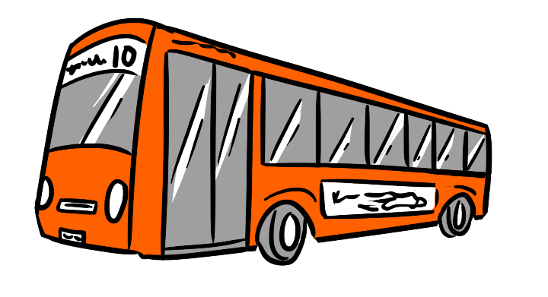

Questions for The Wheels Off The Bus
Set A

Identify key aspects
1. Name two things that the wheels do in the poem.

a. ______________________________ b. ___________________________

2. What does the man in the suit do? Tick one.

make a rude sound cough

look and frown dribble

3. Look at the way the poem is written. Find and copy the words that rhyme with off.

a. _________________________ b. ______________________

Vocabulary
4. As the gran at the back gives a massive huge cough…

Tick another word that could be used to describe this cough.
Tick one.
tiny

loud

sneeze

quiet

5. The body of the bus bumps to the ground…
What does this line in the poem mean?

_______________________________________________________________________________________

_______________________________________________________________________________________

6. Look at the beginning of the poem.
Which word means the same as noise?

________________________________

Inference
7. Look at the third verse of the poem.
Why doesn’t the driver know what to say?
Tick one.

The lady coughed. He is shocked.

He can’t talk. He is shy.

8. Why does the poem end with ‘Stuck in the town’ instead of ‘All through the town?’

_______________________________________________________________________________________

_______________________________________________________________________________________

_______________________________________________________________________________________

_______________________________________________________________________________________

Sequence
9. Draw a line to show which sentence opener is from the beginning, middle and end of the poem.

The toddler dribbles.
beginning

The passengers are puzzled.
middle

The man frowns.
end

Predict
10. What do you think the bus passengers will do next?

_______________________________________________________________________________________

_______________________________________________________________________________________

_______________________________________________________________________________________

_______________________________________________________________________________________

Questions for The Wheels Off The Bus
Set B

Identify key aspects
1. Where is the bus travelling?
Tick one.
through the countryside

through the forest

through the town

on the beach

2. How many verses are there in the poem?

____________________________

3. Why do the passengers rock and sway?

_______________________________________________________________________________________

_______________________________________________________________________________________

Vocabulary:
4. What does the word froth tell us about the toddler’s dribble?
Tick one.
It is blue. It is bubbly.

It is wet. It is noisy.

5. Find and copy the phrase that tell us the passengers don’t follow after the wheels.

________________________________________

6. What does the word puzzled mean?
Tick one.
playing

sad

confused

frightened

Inference
7. Look at the end of the poem.
Why do you think the girl at the front made another rude sound? Tick one.

She likes making rude noises.

She is angry about the wheels falling off.

Explain why you think this.

_______________________________________________________________________________________

_______________________________________________________________________________________

_______________________________________________________________________________________

8. Why do the passengers ‘just stare around’?

_______________________________________________________________________________________

_______________________________________________________________________________________

_______________________________________________________________________________________

Predict
9. What do you think the man in the suit will do now that the bus has broken down?

_______________________________________________________________________________________

_______________________________________________________________________________________

Sequence
10. Write what the wheels do in the right order.

Draw a line to show which sentence opener is from the beginning, middle and end of the poem.

are falling off
first

roll away
second

go round and round
third

Answers for The Wheels Off The Bus
Set A:
Identify key aspects
1. Pupils should choose two of: go round and round; are falling off; roll away.
2. Look and frown
3. a. cough b. froth
Vocabulary
4. loud
5. The answer should make reference to the wheels rolling off so the rest of the bus falls down onto the ground with a bump.
6. sound
Inference
7. He is shocked.
8. Pupils should make reference to the fact that the wheels have fallen off so it now can’t move; it is stuck.
Sequence
9. Draw a line to show which sentence opener is from the beginning, middle and end of the poem.

The toddler dribbles.
beginning

The passengers are puzzled.
middle

The man frowns.
end

Predict
10. What do you think the bus passengers will do next?
Pupils should make a reasonable prediction, perhaps including repeats of the characters’ actions – e.g. the toddler continues dribbling, the old lady coughs again.

Commissioned by The PiXL Club Ltd. July 2019
This resource is strictly for the use of member schools for as long as they remain members of The PiXL Club. It may not be copied, sold nor transferred to a third party or used by the school after membership ceases. Until such time it may be freely used within the member school.
All opinions and contributions are those of the authors. The contents of this resource are not connected with nor endorsed by any other company, organisation or institution.
PiXL Club Ltd endeavour to trace and contact copyright owners. If there are any inadvertent omissions or errors in the acknowledgements or usage, this is unintended and PiXL will remedy these on written notification.

© Copyright The PiXL Club Limited, 2019

Answers for The Wheels Off The Bus
Set B:
Identify key aspects
1. through the town
2. four
3. Because the wheels are falling off, making the bus move around more.
Vocabulary:
4. It is bubbly.
5. left behind
6. confused
Inference
7. Pupils may select either, justifying their choice. For example, ‘The girl likes making rude noises because she was doing that at the start of the poem and I think she just keeps on doing it’, or ‘I think she makes another rude sound because she is cross that the wheels have fallen off and they are all stuck.’
8. Accept answers making reference to them being confused and shocked because the wheels have fallen off and rolled away, and that they are now stuck. They don’t know what to do or what to say.
Predict
9. Accept appropriate predictions, which may include look around and frown again, or get off and walk as he is late for work.
Sequence
10.
are falling off
first

roll away
second

go round and round
third

Commissioned by The PiXL Club Ltd. July 2019
This resource is strictly for the use of member schools for as long as they remain members of The PiXL Club. It may not be copied, sold nor transferred to a third party or used by the school after membership ceases. Until such time it may be freely used within the member school.
All opinions and contributions are those of the authors. The contents of this resource are not connected with nor endorsed by any other company, organisation or institution.
PiXL Club Ltd endeavour to trace and contact copyright owners. If there are any inadvertent omissions or errors in the acknowledgements or usage, this is unintended and PiXL will remedy these on written notification.

© Copyright The PiXL Club Limited, 2019

