Reading extract and questions:
Year 2
Deciduous and Evergreen Trees
Set A/B
Have you ever wondered why some trees keep their leaves all year long and some trees don’t? Read on to find out more…
Introduction
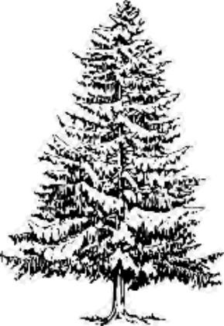
We have lots of different types of trees in the UK. These trees can be sorted into two main groups - deciduous and evergreen. Deciduous sounds like a complicated word, but it just means trees that shed their leaves in the autumn and grow new leaves in the spring. Evergreen is a name for trees that keep their leaves all year long.
Evergreen Trees
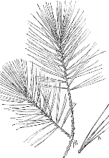
Pine, Spruce, Holly and Fir trees are all evergreen trees. They are grown for lots of different reasons: for shade, for their fruit such as cones (pinecones) and for Christmas trees. These trees only stay green while they are still growing in the ground. If we cut them down, their leaves very quickly turn brown and fall off!
Evergreen trees stay green because they can make their own food all year round. They have thick, waxy leaves which are rolled up tight, like long, thin, green needles. The shape of the leaves allows them to store water in freezing temperatures; this helps them to make food even when there isn’t much sunlight.

Deciduous Trees
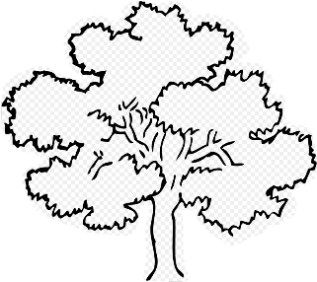
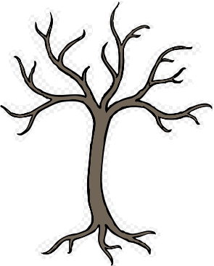
Oak trees are deciduous. These trees lose their leaves before the winter comes. Their leaves turn lots of different colours before finally turning brown and falling off. New leaves start to grow again in March.
Oak trees use their leaves to make food. They need sunlight and water to do this. Because it gets colder and there is less sunlight in winter the trees stop making food, so they don’t need their leaves. They become dormant (they go to sleep) until the springtime comes and there is more sunlight to make food again.
Other deciduous trees that grow in the UK are Ash, Beech and Sycamore trees.

Questions for Deciduous and Evergreen
Trees
Set A
Vocabulary:

1. What does deciduous mean?

_________________________________________________________________

2. Look at the first box. Tick the word which means nearly the same as.

remember different main similar

3. Look at the Deciduous Trees section. Which word means go to sleep? Tick one.

lose

different

dormant

sunlight

Identify key aspects
4. Name two evergreen trees.

1. _______________________________

2. _______________________________

5. How do evergreen trees stay green all year long? Tick one.

They can’t store food.

They can make their own food all year round.

They are planted in the shade.

They shed their leaves in the autumn.

6. What happens to oak trees in the autumn?

_________________________________________________________________

Inference
7. How are evergreen trees useful? Give one way.

_________________________________________________________________

8. Why is sunlight important for trees? Tick one.

It stops them growing in the winter.

It helps them to lose their leaves.

It helps the leaves to turn different colours.

It helps them to make food.

Sequence
9. Number the sections from 1 to 4 to show the order in which they appear. The first has been done for you.
Oak trees are deciduous.
There are two main groups of trees. | 1
Evergreen trees have thick waxy leaves.
Pine, Spruce, Holly and Fir trees are all evergreen trees.

Predict
10. Which trees would make the best trees to stop your neighbours from seeing into your garden? Explain why you think this.

__________________________________________________________________________________

__________________________________________________________________________________

Questions for Deciduous and Evergreen
Trees
Set B

Vocabulary:

1. Look at the first box. Which word is closest in meaning to the word difficult? Tick one.

deciduous

groups

complicated

autumn

2. …it simply means trees that shed their leaves in the autumn…

What does the word shed mean in this sentence? Tick one.

grow lose brown garden

3. What does evergreen mean?

_________________________________________________________________

Identify key aspects
4. What happens if you cut evergreen trees down?

_________________________________________________________________

5. What do trees use their leaves for? Tick one.

shade

making food

keeping cool

sleeping

6. The oak tree is a deciduous tree. Name two other deciduous trees.

1. _______________________________

2. _______________________________

Inference
7. What do deciduous trees look like in winter?

________________________________________________________________________

8. How do deciduous trees help us to work out which season it is?

_________________________________________________________________

Sequence
9. Number the sections from 1 to 4 to show the order in which they appear. The first has been done for you.

New leaves start to grow again in March.
There are lots of different types of trees in our country. | 1
Evergreen trees stay green because they can make their own food all year round.
These trees only stay green while they are still growing in the ground.

Predict
10. Why can’t people keep real Christmas trees in their homes for more than a few weeks?

__________________________________________________________________________________

__________________________________________________________________________________

Answers for Deciduous and Evergreen
Trees

Set A:

Vocabulary:
1. trees that lose their leaves (in Autumn)
2. similar
3. dormant
Retrieval:
4. Accept any two from:
Pine, Spruce, Fir, Holly
5. They can make their own food all year round.
6. they lose their leaves
Inference:
7. Accept any of the following: used for shade/for their fruit (pine cones)/for Christmas trees
8. It helps them to make food/they need it to make food (also accept: they need it to grow)
Summarise:
9.

New leaves start to grow again in March. | 4
There are lots of different types of trees in our country. | 1
Evergreen trees stay green because they can make their own food all year round. | 3
These trees only stay green while they are still growing in the ground. | 2

Predict:
10. Evergreen (accept any name of an evergreen) because they have leaves all year round/are green all year round. Deciduous trees shed their leaves and so the neighbours would be able to see in your garden in the winter.

Commissioned by The PiXL Club Ltd. July 2019
This resource is strictly for the use of member schools for as long as they remain members of The PiXL Club. It may not be copied, sold nor transferred to a third party or used by the school after membership ceases. Until such time it may be freely used within the member school.
All opinions and contributions are those of the authors. The contents of this resource are not connected with nor endorsed by any other company, organisation or institution.
PiXL Club Ltd endeavour to trace and contact copyright owners. If there are any inadvertent omissions or errors in the acknowledgements or usage, this is unintended and PiXL will remedy these on written notification.

© Copyright The PiXL Club Limited, 2019

Answers for Deciduous and Evergreen
Trees

Set B:

Vocabulary:
1. complicated
2. lose
3. trees that keep their leaves all year long/always green
Retrieval:
4. leaves turn brown/fall off
5. making food
6. Accept two of the following: Ash, Beech, Sycamore
Inference:
7. Accept reference to: no leaves/bare/only branches
8. Accept reference to any of the following (including general references to looking at the colour/number of leaves) e.g.
Autumn –the leaves change colour
Winter – when there are no leaves on the trees
Spring – when the leaves start to grow again
Summer – when there are lots of (green) leaves

Summarise:
9.
New leaves start to grow again in March. | 4
There are lots of different types of trees in our country. | 1
Evergreen trees stay green because they can make their own food all year round. | 3
These trees only stay green while they are still growing in the ground. | 2

Predict:
10. Accept reference to the following:
because their leaves will turn brown and fall off/evergreen trees only stay green when they are growing/they will die

Commissioned by The PiXL Club Ltd. July 2019
This resource is strictly for the use of member schools for as long as they remain members of The PiXL Club. It may not be copied, sold nor transferred to a third party or used by the school after membership ceases. Until such time it may be freely used within the member school.
All opinions and contributions are those of the authors. The contents of this resource are not connected with nor endorsed by any other company, organisation or institution.
PiXL Club Ltd endeavour to trace and contact copyright owners. If there are any inadvertent omissions or errors in the acknowledgements or usage, this is unintended and PiXL will remedy these on written notification.

© Copyright The PiXL Club Limited, 2019

