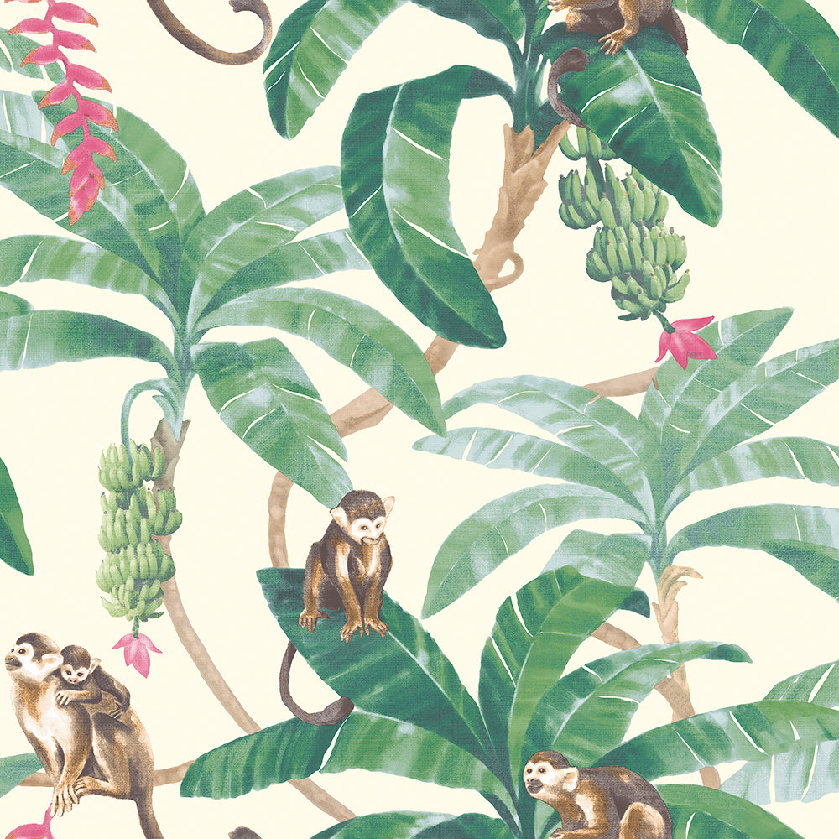

**PE**

On Tuesdays, we will focus on a multi skills development which focuses on the fundamentals of movement. On Fridays, GLK will focus on mastering the fundamental skills needed in team sports.

**Computing,**

The children will continue their work on algorithms and begin to make characters move and change directions to reach designated points. Our new computing curriculum ensures that Ks1 are coding and programming throughout the term.

**Geography**

We shall be looking at the seven continents and different oceans in the world. We will learn where we find rainforests and begin to understand why they are situated where they are. We will identify seasonal and daily weather patterns in the UK and compare them to those of Brazil near the equator and the North and South Poles.

**Music**

The children will experiment with instruments to represent the sounds of the rainforests, learn what different sounds instruments make and use their voices expressively to sing songs. They will learn to play a selected song using a tuned instrument.

**R.E**

In R.E, we will be following the agreed syllabus by Northamptonshire. This term we will begin by exploring stories of Hindu deities and look at major festivals celebrated by Hindus. We will then discover how Hindus worship in their homes and understand different rituals they perform.

In the second half of the term we will return to Christianity and focus on Jesus as a historical figure, focusing on stories about him and finishing with the Easter story.

**Science**During the first half term we will be focusing on animals, including humans, identifying and naming a variety of common carnivores, herbivores and omnivores. We will be looking and comparing the structure of fish, amphibians, reptiles, mammals and birds.

The second half term focuses on plants, identifying different types of plants and understanding the structure of common flowing plants and trees.

**PSHE**

We will be continuing to focus on how to maintain a healthy lifestyle including personal hygiene, before beginning to look at how to keep ourselves safe and protected.

**Maths**

Building on our conceptual knowledge learnt last term, we will be focusing on numbers up to 50 this term. To begin with, the children will be learning how to represent and use number bonds to 20, add and subtract one digit and two digit numbers to 20 (including zero) and solve one-step addition and subtraction problems using concrete and pictorial representations.

The children will then move to counting, reading and writing numbers to 50, understand place value (tens and ones) and be able to represent the numbers using different concrete and pictorial representations. They will continue to use language such as greater than, equal to, less than etc.

Finally, the children will learn to count in multiples of 10s, 5s and 2s.

**Monkey Puzzle**

**Year 1 Spring – 2020**

**English**

Phonics will continue as normal. We are using Read Write Inc. to support the children in extending their phonetic decoding and blending of unfamiliar words,

The children will also continue to learn to spell words containing the 40+ graphemes and will also focus on words which contain the –ed, -ing, -er and –est ending.

During our Talk for Writing sessions we will be learning to use lots of adjectives to describe settings in fiction stories before moving on to fact files. The children will learn about how a fact file is constructed and use this knowledge to create fact files for a variety of animals and Henri Rousseau himself.

**Art / D.T**

In art this term we will be focusing on pattern and texture. Our work will be based on the works of Henri Rousseau and we will be studying his life and jungle paintings. The children will produce observational drawings of wildlife and plant life of the rainforest and look at how they can use different mediums to create texture within their work.

Our Design and Technology lessons will focus on pulleys and levers and the children will experiment creating these mechanisms to complete rainforest challenges.