Create a Fairtrade farm in a shoe box!  What Fairtrade product is growing on your farm? | Congratulations! You are the Head Chef at a new restaurant.  Design a delicious menu that includes where all your ingredients are coming from. | Bake a difference.  With an adult, bake or cook using at least one Fairtrade ingredient.  Decorate your creation with the FAIRTRADE Mark. Take a picture and write down your recipe.
Start your own Fairtrade sticker collection.  When you spot a Fairtrade mark on a piece of fruit or packet in your kitchen, add it to your collection. How many can you collect? | TRADE  Homework Grid | Cocoa trees grow in countries with tropical climates.  Find out what trees grow in the UK and create something to represent this.
The choices that we make can affect the planet and the people that live on it in positive and negative ways.  Design a poster explaining ways that people can make a difference to the planet. | Food is transported around the world in many ways, including on aeroplanes, trucks and ships.  Create your own mode of transport for moving food from one country to another.  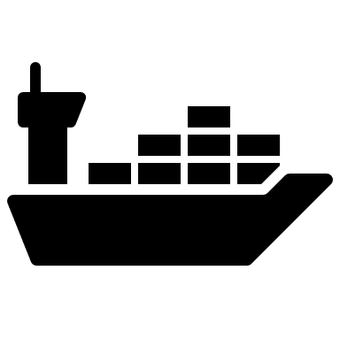 | ‘Plant a seed for a better tomorrow…’  Plant a seed in your garden or in a pot indoors. Research how to look after your plant and watch it grow!

