Time to Hibernate
(Sang to the tune of “the farmer in the den)

It’s time to hibernate.
It’s time to hibernate.
When it’s cold and wintry,
It’s time to hibernate.
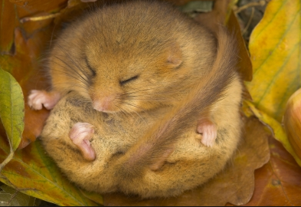
A dormouse curls up tight.
A dormouse curls up tight.
When it’s time to hibernate,
A dormouse curls up tight.

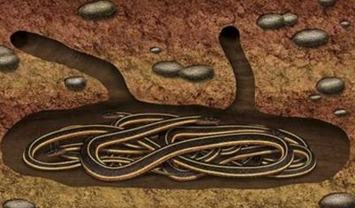
Some snakes sleep underground.
Some snakes sleep underground.
When it’s time to hibernate,
Some snakes sleep underground.
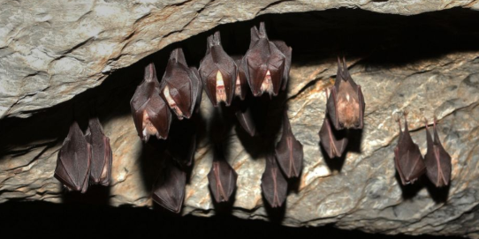
Some bats sleep in the cave.
Some bats sleep in the cave.
When it’s time to hibernate
Some bats sleep in the cave.

Can you think of other animals which hibernate? Can you make up your own verse to the song using your own animal?

