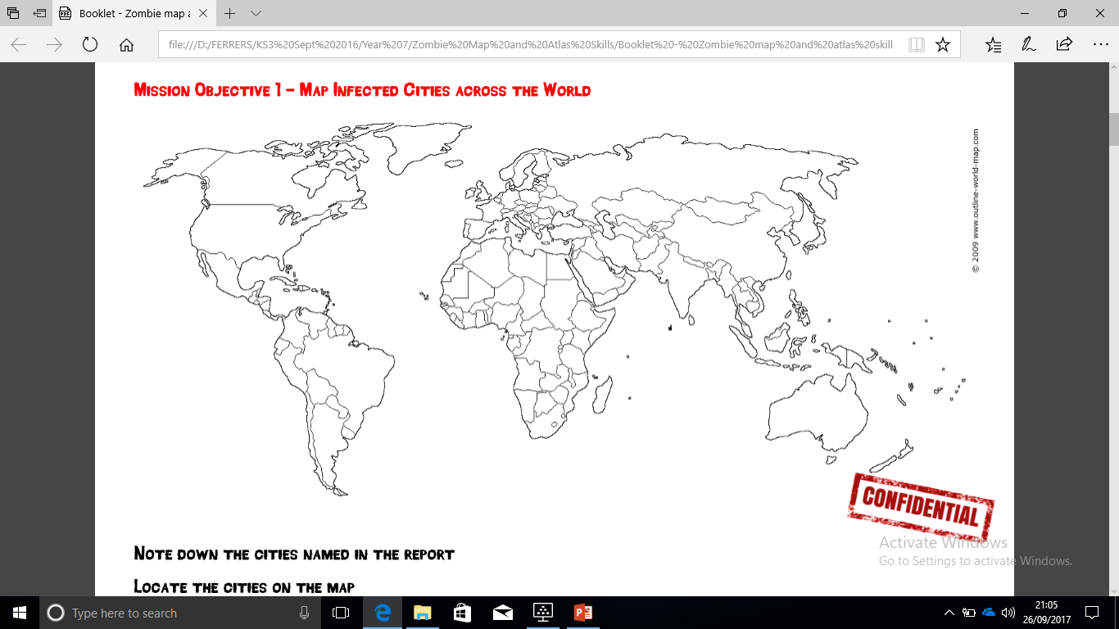

**Mission 1: Cities invaded:**

1. Beijing (China) 2. Hong Kong. 3. Bangkok. 4. Dhaka (Bangladesh) 5. New Delhi.

6. Mumbai. 7. Kathmandu. 8. Islamabad (Pakistan) 9. Karachi.

10. Kabul. 11. Baghdad (Iraq) 12. Tehran.

**Some of the locations infected are located on your map – can you complete the map to achieve mission 1?**

* **Challenge yourself:** Can you describe the spread of the disease so far?

*Think about:* Countries infected so far, continents infected so far, the hemisphere is the disease in so far.

12.

9.

10.

7.

6.

5.

3.

2.

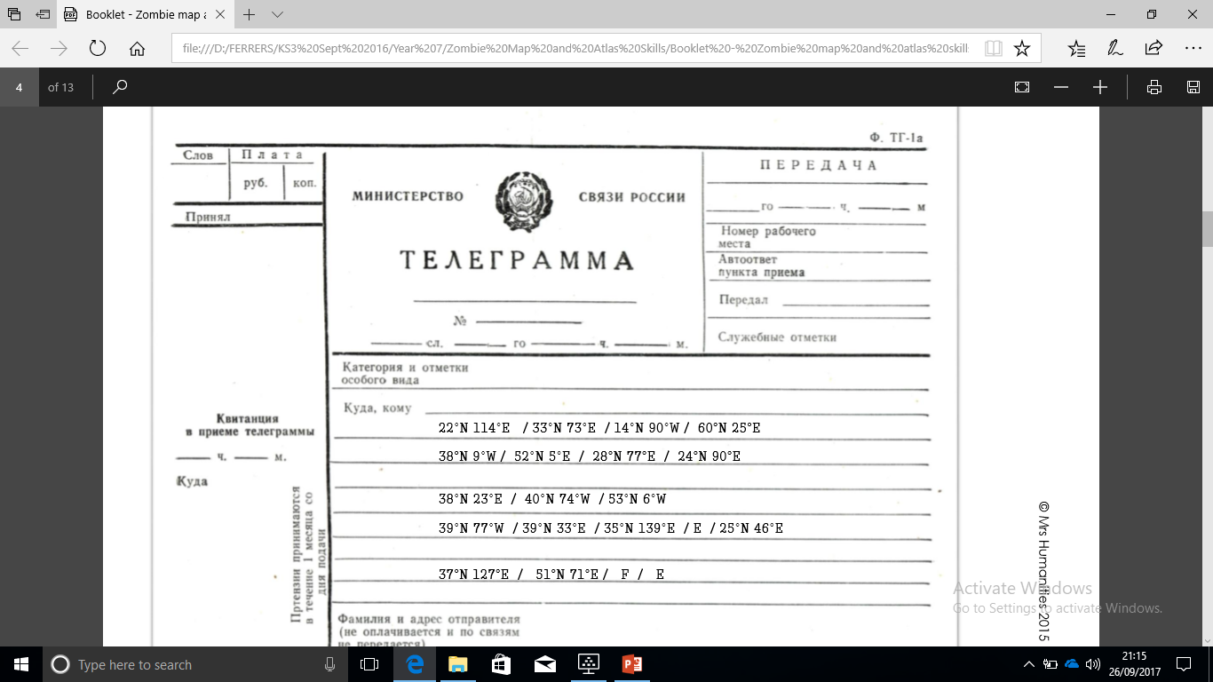

**Mission 2: How to keep safe: Solve the clue! Find the missing locations…**

**Hint:**

**1: Hong Kong**

**2: Islamabad…**

**3: Guate… City**

**4: Hint: In Finland**

**5: Li…**

**6: Hint: In the Netherlands (A)**

**7: Hint: Capital of India.**

**8: Dhaka**

**9: Hint: Capital of Greece**

**10: N… Y…**

**11: Hint: In Ireland**

**12: Hint: Capital of USA**

**13: A…**

**14: Hint: Capital of Japan**

**16: Riy…**

**17: Se…**

**18: Astana**

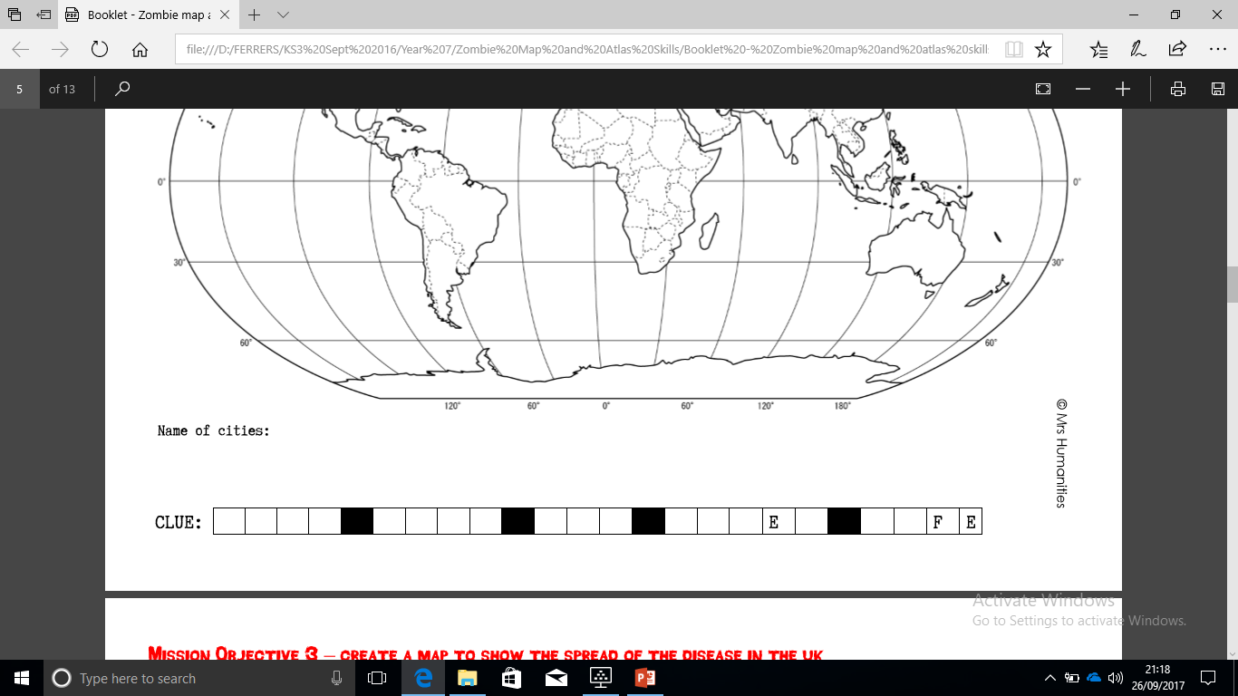

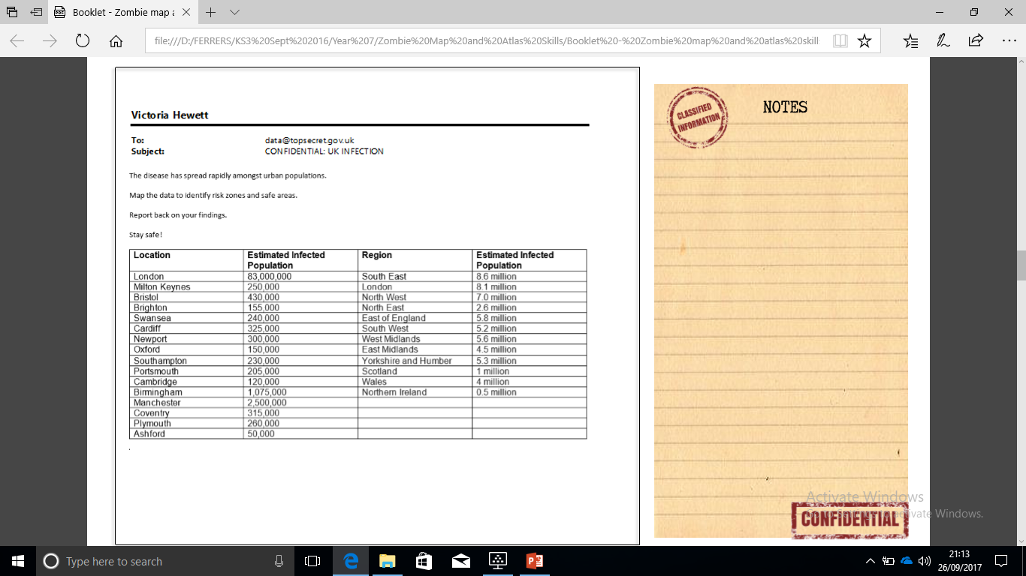

**Missions 3 and 4: Where in the UK?**

The zombies have spread rapidly amongst urban populations.

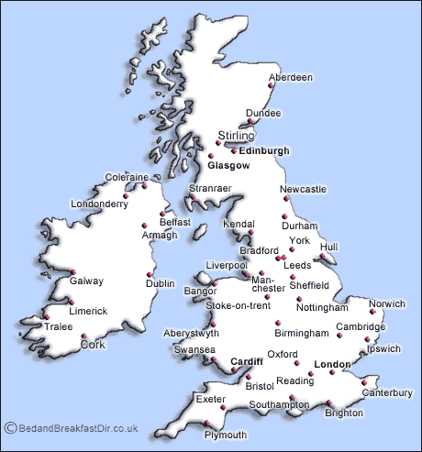

C

N

P

M

M

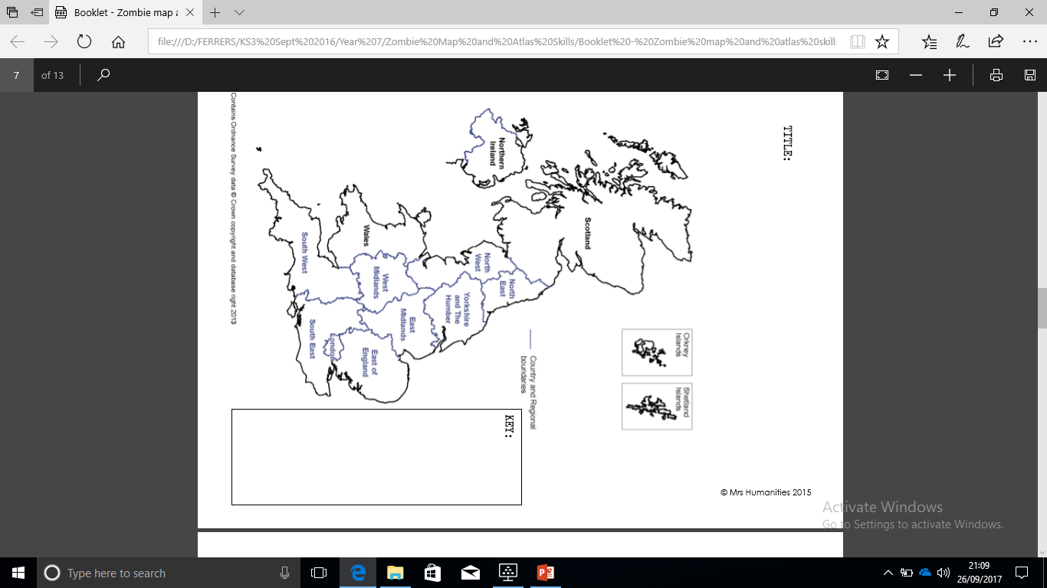

C

N

M

A

P

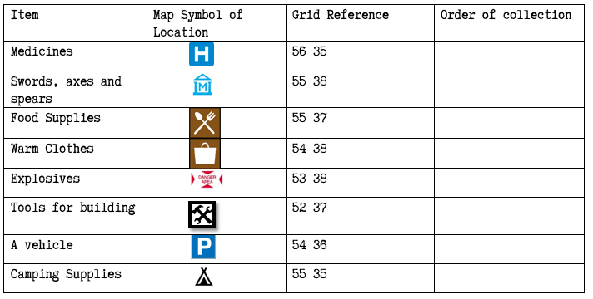

|  |  |
| --- | --- |
| Grid reference: | Order of collection: |
| 56, |  |
|  |  |
|  |  |
| ……, 38 |  |
|  |  |
|  |  |
| 54, 36 |  |
|  |  |

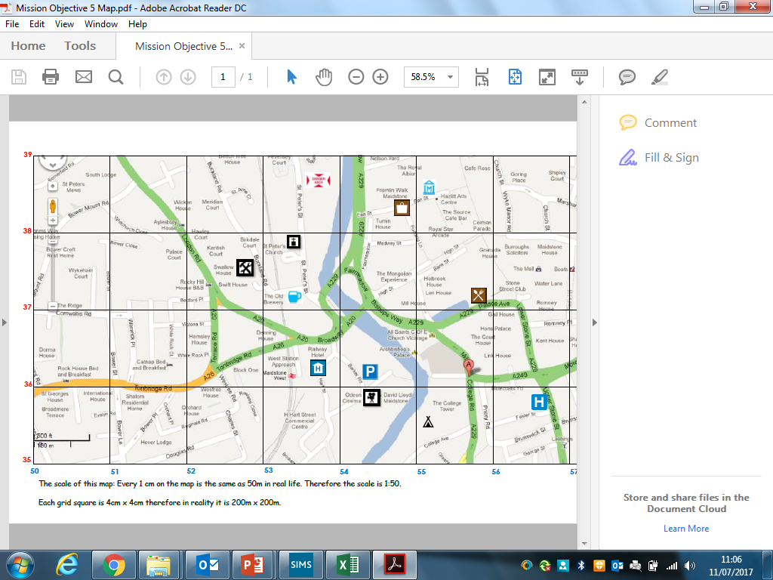

**Mission 6: Mapping our route to supplies…**