How to Make a Homemade Spectroscope

Materials for Homemade Spectroscope
- Empty paper towel roll
- Craft knife and/or scissors
- Blank or old CD
- Pencil
- Small piece of cardboard or cardstock
- Tape
- Paint (optional)

Making a Homemade Spectroscope
1. If you’ll be painting your paper towel roll, you’ll want to do that first and let it dry. (This step isn’t necessary, but it’s hard for us to pass up an opportunity to paint something!)
2. Use a craft knife (an adult should do this) to cut a thin slit at a 45° angle toward the bottom of the cardboard tube.
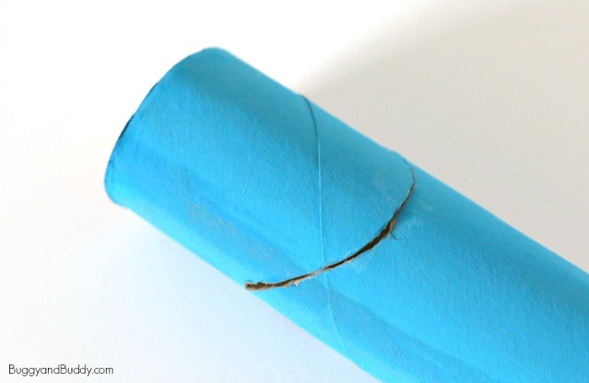

3. Directly across from the slit, make a small peephole or viewing hole using your craft knife (another step for an adult).
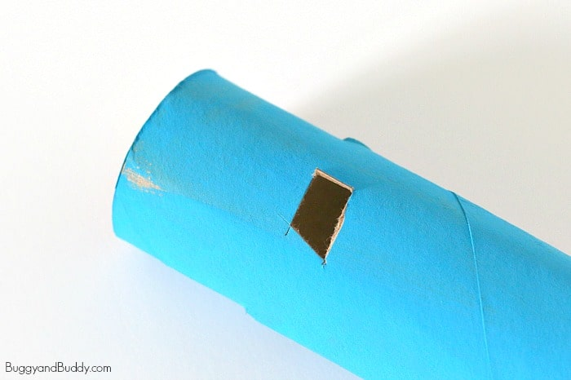

4. Trace one end of your paper towel roll onto your small scrap of cardboard or cardstock. Cut it out.
5. Cut a straight slit right across the center of your cardboard circle.
6. Tape the circle to the top of your spectroscope.

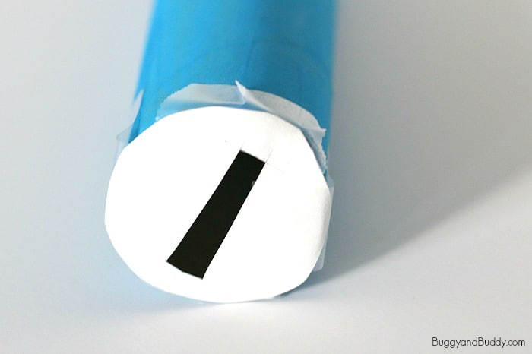

7. Insert the CD into your 45° angled slit with the shiny side facing up.

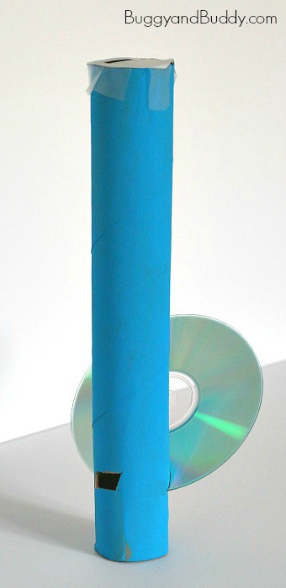

Using the Homemade Spectroscope
Start by taking your spectroscope outside. Point the top slit up at the sky (NOT directly at the sun). Look through the peephole. You will see a rainbow inside!

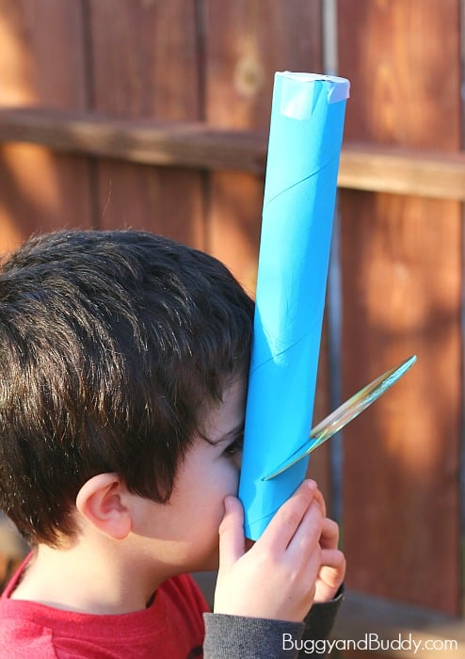
Now try your spectroscope with other light sources like fluorescent light, neon light and candle light. Compare what you see!

What’s going on?
A CD is a mirrored surface with spiral tracks or pits. These tracks are evenly spaced and diffract light (separating the colors). Because the CD’s surface is mirrored, the light is reflected to your eye.

