Home Learning Update

Remember to go on Spelling Shed to complete the assignments.

Create a rainbow picture and put it in your window.

Create an Andy Goldsworthy style piece of art, using natural materials found in your garden.
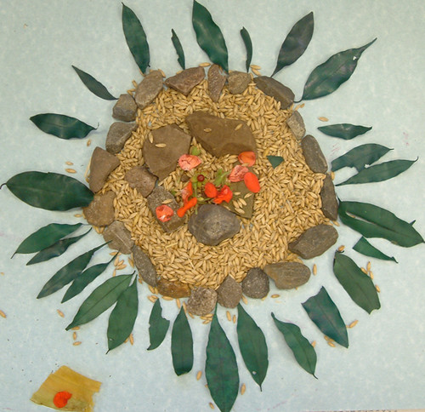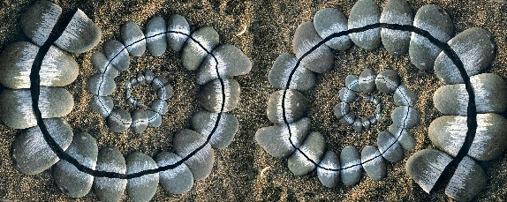

Create a maths quiz for your family to answer.

Do some baking.

With your parent’s permission, send some photographs to the school twitter account so we can see what you have created.
@bozeatpri

