AMAZON HOMEWORK GRID
QUIZ TIME | POETRY | DESCRIPTION | WHAT’S SIMILAR?  WHAT’S DIFFERENT?
Design a quiz with 10 questions about the rainforest. Remember to include the answers! Can you play your quiz with different members of  your family? | Write an acrostic poem  about the rainforest –  each line must contain a  description or information about the  rainforest. Can you even  make it rhyme?  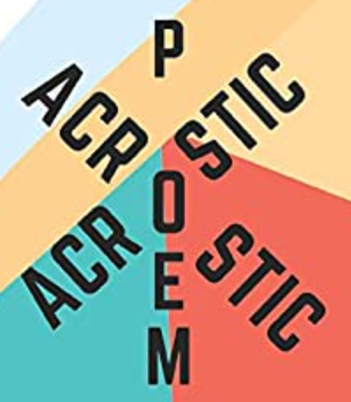 | Imagine you are walking through a rainforest, write a description of your experience – include what you can see, hear, feel, and touch.  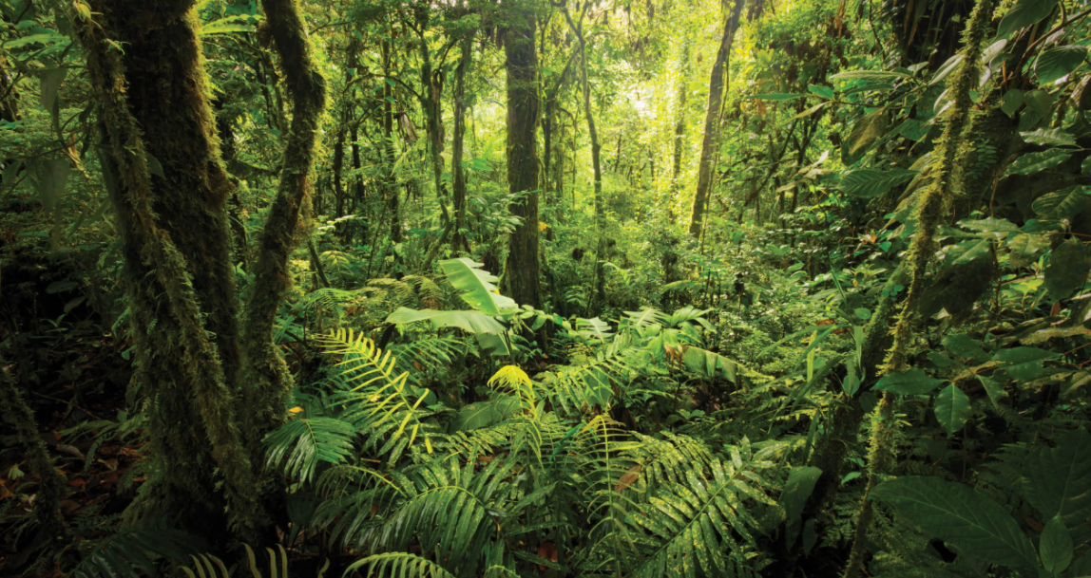 | Make a table showing  the similarities and  differences between  South America and  Africa.  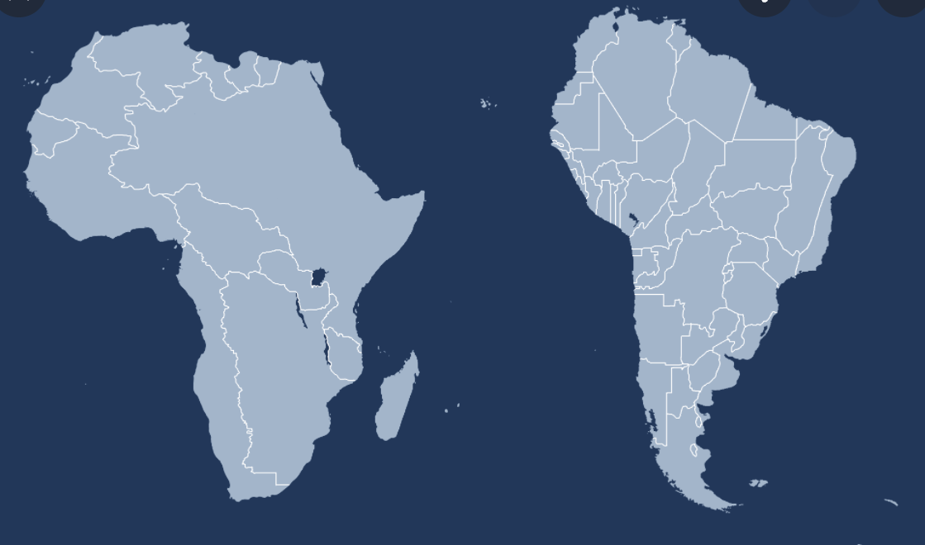
More on back!
RIVER FACTFILE | WATCHING | DESIGN | DID YOU KNOW?
Find 10 facts about the  Amazon River or Congo  river. e.g. length, source,  wildlife, countries it runs  through etc. Can you  work out which is  bigger?  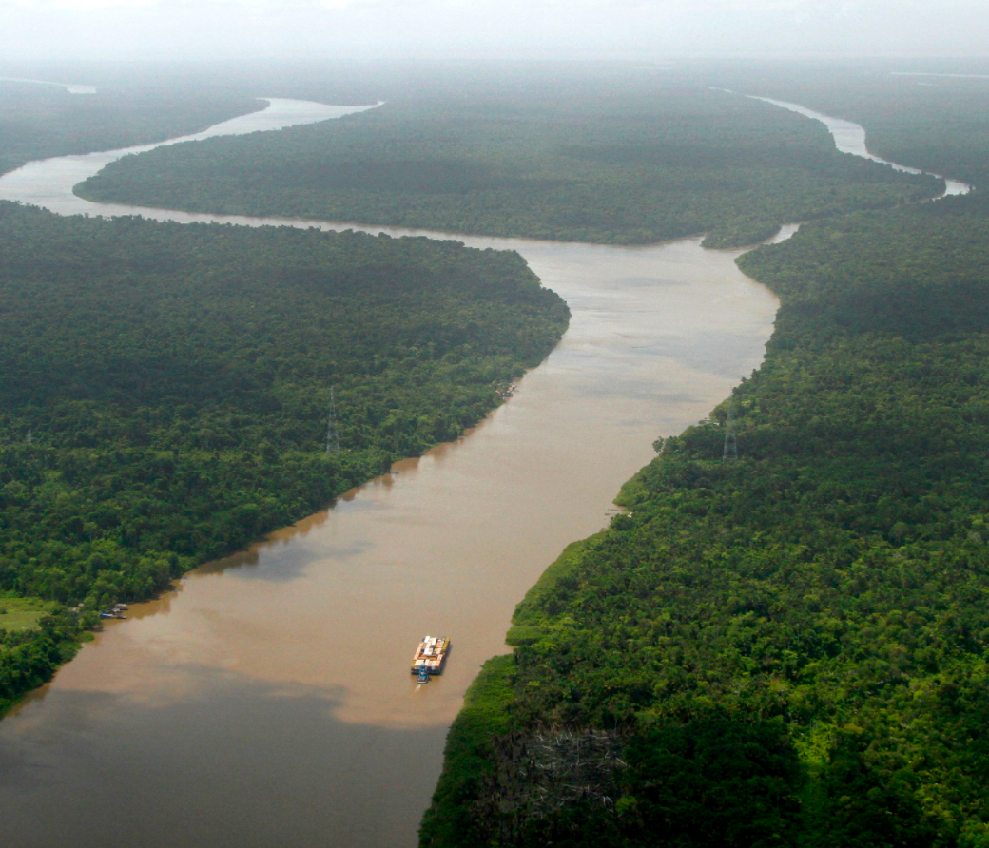 | Enjoy watching this  video about life in the  rainforest in Guyana.  https://www.bbc.co.uk/teach/class-clips-video/geography-ks2-ks3-life-in-guyanas-rainforests/zv7scqt  Create an information  poster showing all you  learnt from the video.  Your poster should be  informative and eye catching.  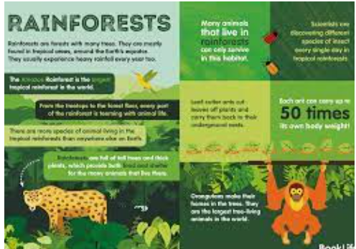 | Create your own rainforest model/collage  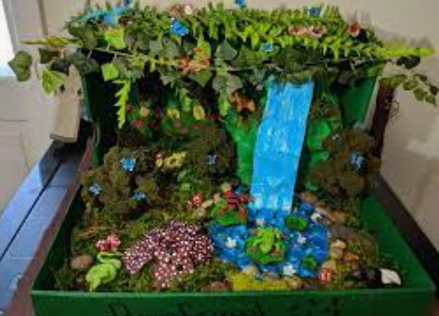 | Create your own amazing facts about the  rainforests.  Create ‘did you know?’ fact cards and teach your  new found knowledge to your friends and family.

Children should choose at least 4 things on the list that they would enjoy doing – Homework is due in the Friday after half term- November 5th 2021 – We look forward to seeing your wonderful creations!

