Editing Package
Prove Me Wrong
Task 3
Y 3/4

Secretarial editing

Commissioned by The PiXL Club Ltd.
November 2019
This resource is strictly for the use of member schools for as long as they remain members of The PiXL Club. It may not be copied, sold nor transferred to a third party or used by the school after membership ceases. Until such time it may be freely used within the member school.
All opinions and contributions are those of the authors. The contents of this resource are not connected with nor endorsed by any other company, organisation or institution.
PiXL Club Ltd endeavour to trace and contact copyright owners. If there are any inadvertent omissions or errors in the acknowledgements or usage, this is unintended and PiXL will remedy these on written notification.

© Copyright The PiXL Club Limited, 2019

Secretarial editing Task 3
1. Read the following text from a news report.

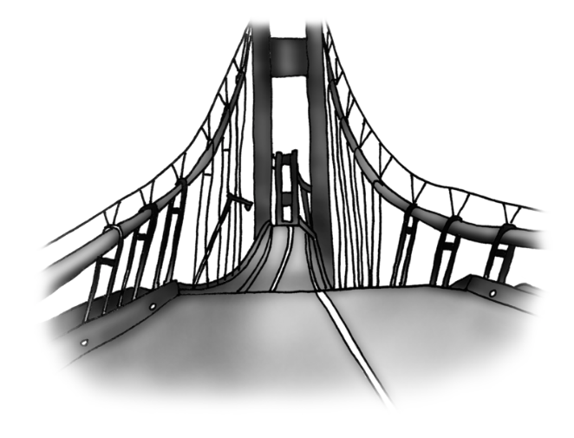

High winds close bridge

The swafflow river Bridge was closed to all traffic yesterday as gale-force winds buffeted the town.

The extream weather conditions had cause the road surface to twist and buckle and some of the bridges supporting cables had begun to work loose. Police officers was quickly on the scene, blocking off the road and setting up diversions while engineers were called in to assessed the damage

A police spokesperson said that this was the most powerful storm the area had experienced this centry. They acknowledged that the closure had caused difculties for some drivers but their priority was to prevent acidents and keep the public safe.

2. After reading the extract, check for the following aspects and underline them:
- Check if there are any punctuation mistakes.
- Check if there are any spelling mistakes – use a dictionary for tricky words.
- Check if there are any grammar mistakes.
- Identify a feature which could be improved.

3. Complete the grid below.
List any punctuation mistakes.
List any spelling mistakes.
List any grammar mistakes.
Identify a feature which could be improved.

4. Rewrite the extract, making the amendments which you have identified in the grid above.
______________________________________________________________________________________________________________________________________________________________________________________________________________________________________________________________________________________________________________________________________________________________________________________________________________________________________________________________________________________________________________________________________________________________________________________________________________________________________________________________________________________________________________________________________________________________________________

