Editing Package
Prove Me Wrong
Task 1
Y 3/4

Secretarial editing

Commissioned by The PiXL Club Ltd.
November 2019
This resource is strictly for the use of member schools for as long as they remain members of The PiXL Club. It may not be copied, sold nor transferred to a third party or used by the school after membership ceases. Until such time it may be freely used within the member school.
All opinions and contributions are those of the authors. The contents of this resource are not connected with nor endorsed by any other company, organisation or institution.
PiXL Club Ltd endeavour to trace and contact copyright owners. If there are any inadvertent omissions or errors in the acknowledgements or usage, this is unintended and PiXL will remedy these on written notification.

© Copyright The PiXL Club Limited, 2019

Secretarial editing Task 1

- Read the following extract from a non-chronological report about keeping fit.

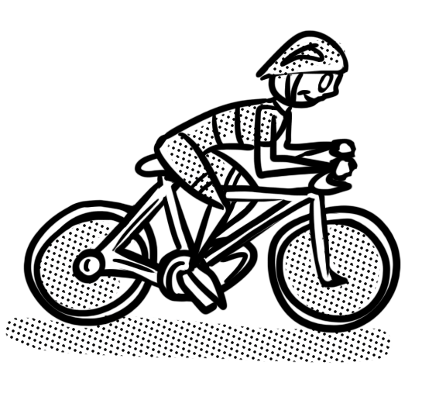
Another excellent form of exersize is cycling. It really build up the strength in your leg muscles. It can also improve your stamina, as long as you cycles hard enough to get out of breathe. However, you do have to think about your safety first of all, make sure that you have correct protective gear, such as a helmet. It is probbly also a good idear to take plenty of water if your going on a long ride. Finally, dont go on the roads unless you have been properly trained by experts. Why not ask about cycle proficiency today.

2. After reading the extract, check for the following aspects and underline them:
- Check if there are any punctuation mistakes.
- Check if there are any spelling mistakes – use a dictionary for tricky words.
- Check if there are any grammar mistakes.
- Identify a feature which could be improved.

3. Complete the grid below.
List any punctuation mistakes.
List any spelling mistakes.
List any grammar mistakes.
Identify a feature which could be improved.

4. Rewrite the extract, making the amendments which you have identified in the grid above.
______________________________________________________________________________________________________________________________________________________________________________________________________________________________________________________________________________________________________________________________________________________________________________________________________________________________________________________________________________________________________________________________________________________________________________________________________________________________________________________________________________________________________________________________________________________________________________

