Editing Package
Prove Me Wrong
Task 3
Y 3/4

Editing for meaning

Commissioned by The PiXL Club Ltd.
November 2019
This resource is strictly for the use of member schools for as long as they remain members of The PiXL Club. It may not be copied, sold nor transferred to a third party or used by the school after membership ceases. Until such time it may be freely used within the member school.
All opinions and contributions are those of the authors. The contents of this resource are not connected with nor endorsed by any other company, organisation or institution.
PiXL Club Ltd endeavour to trace and contact copyright owners. If there are any inadvertent omissions or errors in the acknowledgements or usage, this is unintended and PiXL will remedy these on written notification.

© Copyright The PiXL Club Limited, 2019

Editing for meaning Task 3

- Read the extract below.

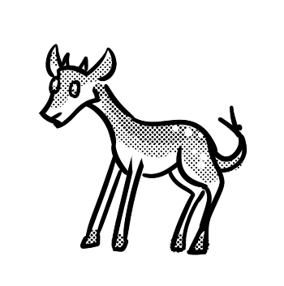
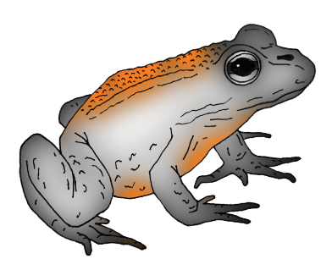
A walk on the wild side

Where can you take your kids for a fun day out that exercises their minds as well as their bodies. Look no than Saxon Wood.

Saxon Wood was so more than just an area of outstanding natural beauty. It has wooden sculptures of people and animals from olden stories like Little Red Riding Hood and The Three Little Pigs and so on that the younger children will enjoy. There is a massive adventure playground packed with thrilling equipment to scramble over. There is even a nature study centre, complete with a lake in which to go pond dipping or spotting frogs who could ask for more.

At only £5 per family group, it was also great value. So, pack a picnic, put on your and enjoy a great day out.

2. After reading the extract, check for the following aspects and underline them:
- Check if there are any missing words.
- Check if there is any missing punctuation.
- Check if there are any problems with the tense.
- Find at least one part that could be improved.

3. Complete the grid below.
List any missing words.
List any missing punctuation.
List any problems with the tense.
Write a sentence which could be improved.

4. Rewrite the extract, making the amendments which you have identified in the grid above.
______________________________________________________________________________________________________________________________________________________________________________________________________________________________________________________________________________________________________________________________________________________________________________________________________________________________________________________________________________________________________________________________________________________________________________________________________________________________________________________________________________________________________________________________________________________________________________

