Editing Package
Prove Me Wrong
Task 2
Y 3/4

Editing for meaning

Commissioned by The PiXL Club Ltd.
November 2019
This resource is strictly for the use of member schools for as long as they remain members of The PiXL Club. It may not be copied, sold nor transferred to a third party or used by the school after membership ceases. Until such time it may be freely used within the member school.
All opinions and contributions are those of the authors. The contents of this resource are not connected with nor endorsed by any other company, organisation or institution.
PiXL Club Ltd endeavour to trace and contact copyright owners. If there are any inadvertent omissions or errors in the acknowledgements or usage, this is unintended and PiXL will remedy these on written notification.

© Copyright The PiXL Club Limited, 2019

Editing for meaning Task 2

- Read the extract below.

Dear Sir or Madam,

I am writing to express my deep gratitude for the outstanding you provided for my father when he stayed at your hospital last week. He was admitted on Tuesday. He had concerns about his heart. He was immediately given a number of tests to what the problem was.

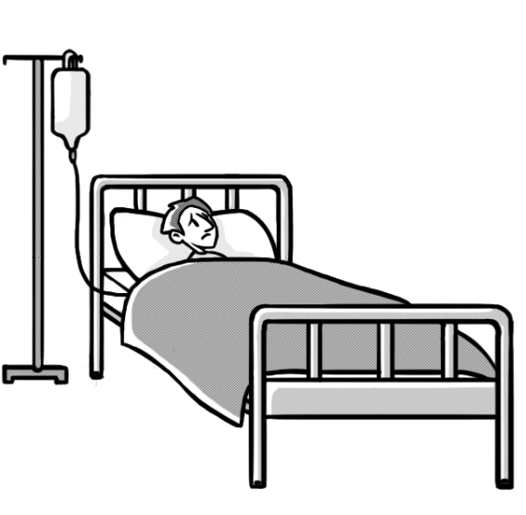
Meanwhile, he is made to feel very comfortable and your nurses and care assistants do a wonderful job in reassuring him. The compassion and professionalism with which he was treated was a great credit to you all. What an amazing group of people you are. I cant thank you enough.

Yours faithfully,

2. After reading the extract, check for the following aspects and underline them:
- Check if there are any missing words.
- Check if there is any missing punctuation.
- Check if there are any problems with the tense.
- Find at least one part that could be improved.

3. Complete the grid below.
List any missing words.
List any missing punctuation.
List any problems with the tense.
Write a sentence which could be improved.

4. Rewrite the extract, making the amendments which you have identified in the grid above.
______________________________________________________________________________________________________________________________________________________________________________________________________________________________________________________________________________________________________________________________________________________________________________________________________________________________________________________________________________________________________________________________________________________________________________________________________________________________________________________________________________________________________________________________________________________________________________

