Editing Package
Prove Me Wrong
Task 1
Y 3/4

Editing as you go

Commissioned by The PiXL Club Ltd.
November 2019
This resource is strictly for the use of member schools for as long as they remain members of The PiXL Club. It may not be copied, sold nor transferred to a third party or used by the school after membership ceases. Until such time it may be freely used within the member school.
All opinions and contributions are those of the authors. The contents of this resource are not connected with nor endorsed by any other company, organisation or institution.
PiXL Club Ltd endeavour to trace and contact copyright owners. If there are any inadvertent omissions or errors in the acknowledgements or usage, this is unintended and PiXL will remedy these on written notification.

© Copyright The PiXL Club Limited, 2019

Editing as you go Task 1

- Read the extract below.

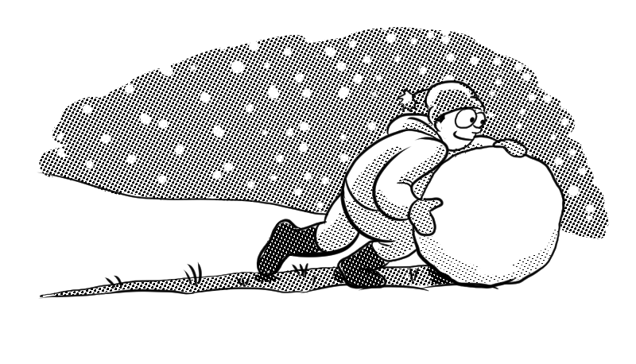
Water is one of the phew substances on our planet what can be found naturally in all three states – solid, liquid and gas. We is probably most familiar with it as a liquid as a liquid in what we in the seas and rivers drink around us. Although water vapour is an invisible gas, we can notiss it beginning to become liquid again in the clouds above us. Meanwhile, at the poles, or during winter, we see it in a sold state as ice and snow.

2. After reading the extract, check for the following aspects and underline them:
- Check if there is anything that does not make sense.
- Check if there are any spelling or grammar mistakes.
- Find at least one part that could be improved.

3. Complete the grid below.
List parts that do not make sense.
List any spelling mistakes.
List any grammar mistakes.
Write a sentence which could be improved.

4. Rewrite the extract, making the amendments which you have identified in the grid above.
______________________________________________________________________________________________________________________________________________________________________________________________________________________________________________________________________________________________________________________________________________________________________________________________________________________________________________________________________________________________________________________________________________________________________________________________________________________________________________________________________________________________________________________________________________________________________________

