Editing Package
Prove Me Wrong
Task 1
Y3 and Y4

Using full stops correctly

Commissioned by The PiXL Club Ltd.
January 2020

© Copyright The PiXL Club Limited, 2020

Y3 Using full stops correctly Task 1
1. Read the extract of the recount below.

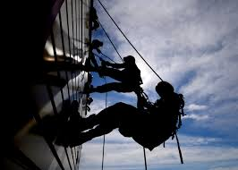
Last week. I went to watch my brother and his friends take part in a charity abseil event He chose to do this so that he could raise money for a charity which is very special to him. It is called ‘Hope’ and helps sick children in our local hospital Altogether, the group raised £400 so they were really proud of their achievement. My brother was the first person in the group to abseil down the building He shouted to everyone at the bottom. I couldn’t hear because he was so high up!. They chose to abseil down the front of our hospital where the charity is based Some of the children were able to watch from behind the windows. They waved to my brother as he abseiled past. What a wonderful day!.

2. After reading the extract, check that full stops have been used correctly and choose where changes have to be made.
Make the changes by rewriting out the extract ensuring that all full stops are correct.
________________________________________________________________________________________________________________________________________________________________________________________________________________________________________________________________________________________________________________________________________________________________________________________________________________________________________________________________________________________________________________________________________________________________________________________________________________________________________________________________________________________________________________________________________________________________________________________________________________________________________________________________________________________________________________________________

3. Which option uses full stops correctly?

The car drove. Down the busy street.
She ate all her lunch really quickly
John couldn’t see. I was blocking his view.
The books were on. The bookshelf.

4. Add a full stop in the correct place in the sentence below.

Tommy thought that the best part of the holiday was the swimming I thought it was the camel ride.

