REFRACTION CIRCUS INSTRUCTIONS

**THE SURPRISING COIN**

• When the cup is  
empty, look at the coin.

• Move to the side until you  
can no longer see the coin  
over the edge of the cup.

• Keep still, looking at the cup.

• Ask a partner slowly to  
fill the cup with water, not  
touching or moving the cup.

• Don’t move your head.  
Keep looking at the coin and  
notice what happens.

• Empty the water from  
the cup back into  
the water  
container and  
try it again.

**WATER MAGNIFIER**

• Look at the sheet of newspaper closely.

• Place the plastic sheet over the newspaper and look at the print closely, to see if there is any change.

• Use the matchstick to transfer a small drop of water from the cup to the sheet of plastic; you may need a few drops but don’t put too much on.

• Look at the writing through the drop of water. Is anything different? Try sliding the plastic sheet gently from side to side.

• Now try looking at the newspaper through a magnifying glass and a glass bead. See if you can make any more observations, to compare what you can see with a normal eye and through a water drop, a magnifying glass and a glass bead.

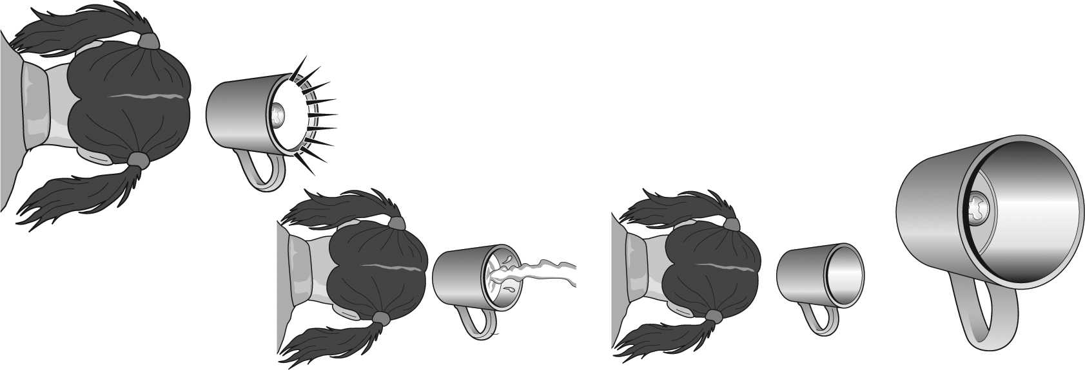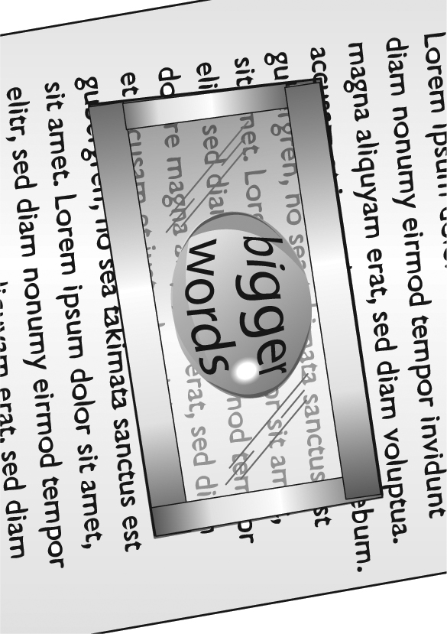

REFRACTION CIRCUS INSTRUCTIONS

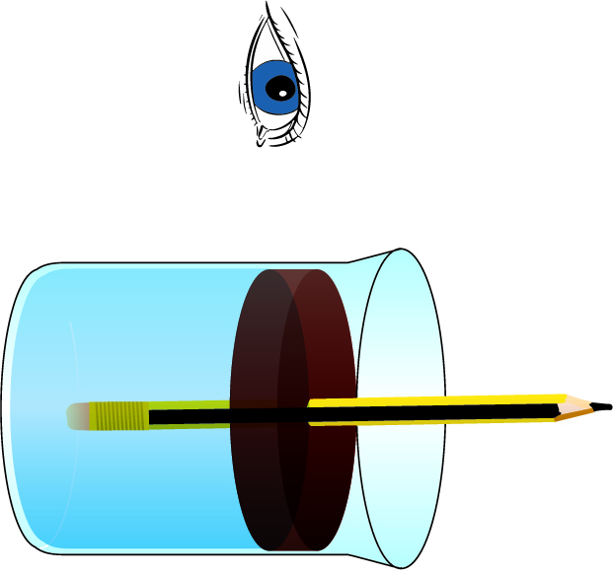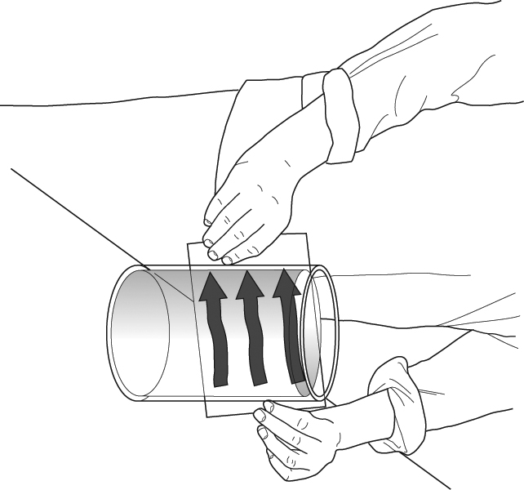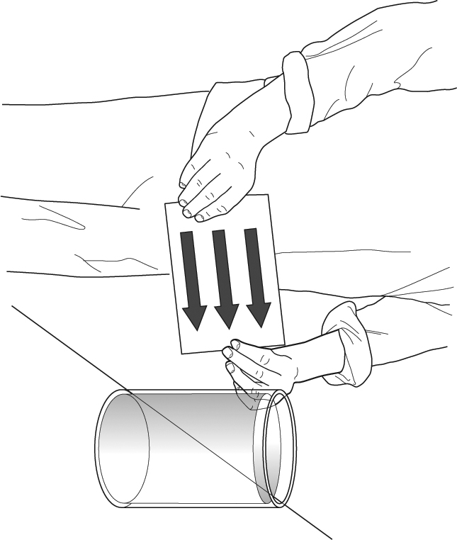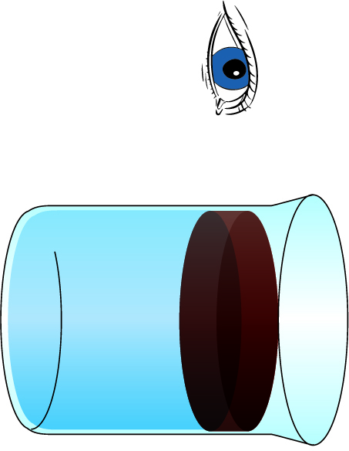

water

oil

**AMAZING ARROWS**

• Take the  
card with  
the three  
arrows on  
and hold it  
behind the  
jar of water.

• Move the card around a little behind  
the water jar and notice  
what happens  
to the arrows.

• Turn the card  
around and repeat  
the activity.

water

oil

**OIL, WATER AND A PENCIL**

• Look at the  
pencil and  
check that it is  
straight, not bent.

• Move you head so it  
is on a level with the  
jar from the side.

• Ask your partner to place and  
hold the pencil upright into the jar.

• Observe what the pencil looks like.

• Ask your partner to tilt the pencil from  
side to side, keeping  
the bottom of the  
pencil touching the  
bottom of the beaker  
in the middle.  
Observe what  
the pencil  
looks like.