Editing Package
Prove Me Wrong
Task 2
Y3 and Y4

Using capital letters correctly

Commissioned by The PiXL Club Ltd.
January 2020

© Copyright The PiXL Club Limited, 2020

Y4 Using capital letters correctly Task 2

1. Read the extract of the non-chronological report below.
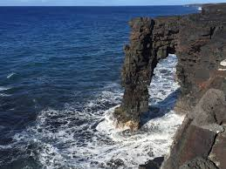

There are many different types of coasts. each type of coast has unique characteristics. Some coasts have a rocky shore, for example at the kenai fjords national park in Alaska. The rocky type of shore is especially popular with seabirds like the razorbill. They love to build their homes among the rocks. the beaches we usually go to have a sandy shore. it is often possible to see small crabs burrowing in the sand there.
Coasts also are described as being either Cliffed or Flat. A cliffed coast has been created when wind and waves cause huge cliffs above the sea level. A flat coast is when the Land gradually descends into the sea.

2. After reading the extract, check that capital letters have been used correctly and choose where changes have to be made.
Make the changes by rewriting out the extract ensuring that all capital letters are correct.
______________________________________________________________________________________________________________________________________________________________________________________________________________________________________________________________________________________________________________________________________________________________________________________________________________________________________________________________________________________________________________________________________________________________________________________________________________________________________________________________________________________________________________________________________________________________________________

3. Circle the incorrectly placed capital letter in the sentence below.
The Airline travels to Gatwick Airport every Monday and Thursday.

4. Insert two capital letters in the sentences below.
Each saturday, the village holds an arts and crafts fair. it is very well attended.

