Editing Package
Prove Me Wrong
Task 3
Y 3/4

Editing for impact

Commissioned by The PiXL Club Ltd.
November 2019
This resource is strictly for the use of member schools for as long as they remain members of The PiXL Club. It may not be copied, sold nor transferred to a third party or used by the school after membership ceases. Until such time it may be freely used within the member school.
All opinions and contributions are those of the authors. The contents of this resource are not connected with nor endorsed by any other company, organisation or institution.
PiXL Club Ltd endeavour to trace and contact copyright owners. If there are any inadvertent omissions or errors in the acknowledgements or usage, this is unintended and PiXL will remedy these on written notification.

© Copyright The PiXL Club Limited, 2019

Editing for impact Task 3

- Read the extract below.

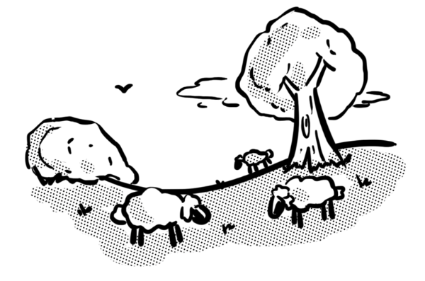
It was a nice day. The sky was blue. The birds were singing. The clouds were flying by. The sheep were in the field. Rip! Scrunch! They were eating grass. They were happy. Suddenly, one of them bleated. She had lost her lamb! There it is! The lamb is safe! The lamb was behind a tree. The lamb walks over to its mother. The lamb starts to eat grass.

2. After reading the extract, check for the following aspects and underline them:
- Check if there are any words that could be improved.
- Check whether the pronouns and conjunctions help the text to flow.
- Check that the tense is consistent.
- Identify places where the sentence lengths could be improved.

3. Complete the grid below.
List words that could be improved.
Identify places where pronouns or conjunctions could be improved.
Identify any problems with the tense.
Identify where sentence lengths could be improved.

4. Rewrite the extract, making the amendments which you have identified in the grid above.
______________________________________________________________________________________________________________________________________________________________________________________________________________________________________________________________________________________________________________________________________________________________________________________________________________________________________________________________________________________________________________________________________________________________________________________________________________________________________________________________________________________________________________________________________________________________________________

